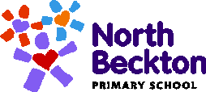
Our North Beckton Curriculum

At North Beckton, the vision for our curriculum is that all pupils will attain the necessary academic skills and knowledge during their time with us, to be able to successfully transition into the next phase of their learning in conjunction with building the key transferable skills necessary to equip them for their life beyond formal education - as successful adults.

Our ‘Curriculum Logo’ is a visual representation of the curriculum areas that the pupils learn during their time with us. The central figure demonstrates our priority areas, which includes embedding a Love of Reading and our Time for Us curriculum. The figure on the left extends and balances our learning into a broad base of both subject knowledge and progressive skill building. These are combined to create engaging, integrated learning within each year group covering three overarching themes throughout the year – one per term. Across the school, all the children learn about our shared histories, our current lives and our future world; our pupils will learn from our past to better understand the present in order to shape their futures. This model enables pupils to regularly revisit key skills in order to become increasingly fluent in them whilst constantly developing their knowledge in different subject areas. Our pupils with Special Educational Needs sit within this curriculum structure and the same approach is used to allow an equitable coverage, although this is adapted to meet their individual learning needs.

Whilst we believe that pupils’ reaching their academic potential is essential, our curriculum recognises that our school has so much more to offer. Therefore the figure on the right outlines how our curriculum develops the whole child through the incorporation of different experiences linked to our fundamental North Beckton values. These include: Learning Outside the Classroom; Sharing our Voices; Celebrating our Community; Supporting our Mental Wellbeing; and Developing our Physical Wellbeing. We want our pupils to be confident young people, willing to make mistakes; keen to try new ideas; whilst developing a life-long-love of learning and respect for humanity, society and the environment that is their world.

Most importantly, our curriculum has been designed to celebrate our diverse and inclusive community; We All Belong!
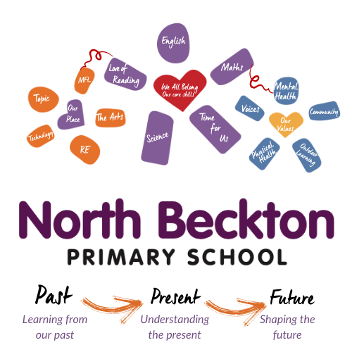

We All Belong: With resilience and respect,
we are all determined to succeed.

We all try our best
Everyone shows respect

Altogether - we are equal
Learning together
Listening to each other

Being kind and understanding
Enjoying friendship
Leading the way
Open to new ideas
No matter what happens, we don’t give up
GO North Beckton GO!
