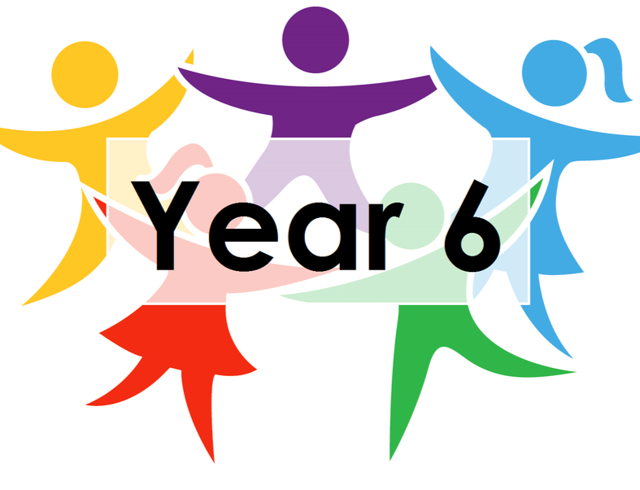

***LEARNING FROM HOME***

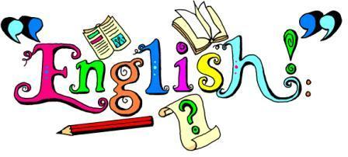

***YEAR 6***  ***– Week Beginning 04.05.20***

**Reading –** Read the next part of Holes and answer the questions (they’re at the end of the document).

**Grammar** – for grammar, we’d like you to look at figurative language. Use the posters to remind yourself about MAPSO and for a challenge, idioms and hyperbole. You can also do the activities on the reference sheets. Then, read the statements on the worksheet and try and decide which piece of figurative language it is.

**Writing** - use the Literacy Shed clips on the attached document as inspiration to write your own poem. You can write any type of poem you like. Remember, in poetry, there aren’t any rules!

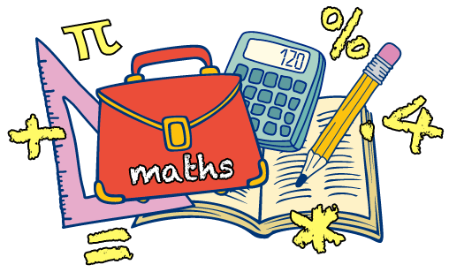

**Maths –** This week, we are going to research a recipe for baking cakes or making bread and write a presentation showing the quantities needed depending on how many people you need to feed. As wells this, you are going to write a set of instructions to help someone in Key Stage 1 learn to read a measuring scale.



**Living things and their habitats.**

What is classification? This week you will be learning what classification is, why it is helpful and how to do it.

Read through the lesson presentation and complete the activity of grouping the animals ready for their new cages in a zoo near you!



**Geography:** This week, we will be learning about trade and economics, particularly between the UK and El Salvador (a country in central/North America). Use the PowerPoint to guide your learning and then do some research of your own. In your travel brochure, add a page called ‘Trade and Economics’ and write down the things that you learn.

**Computing**: This week, we will be using the project feature of Google Earth to create an imaginary journey across the globe, for which you will research and add information. You will then share your journey with one person.

**Art:** Continue thinking about the drawings you made last week last week and create a practise page of self-portraits using a mirror or a photograph of yourself. Use whatever materials you have to hand. Look at the video links for some ideas and inspiration.

**Additional Activities/suggestions:**

Below, Miss Wilcox has shared a picture of herself holding two baby lambs; they are twins – a girl (on the left) and a boy (on the right). Can you think of some names for the lambs? Their breed is Swaledale and they were born in Rosedale Abbey, Pickering, North Yorkshire – you might want to use that information to help name them! Can you do any research about sheep? What do they eat? How can you tell if they’re annoyed? What about drawing a picture of some lambs – you might even draw a scene depicting Spring time.

­­­­­­