The Port Key
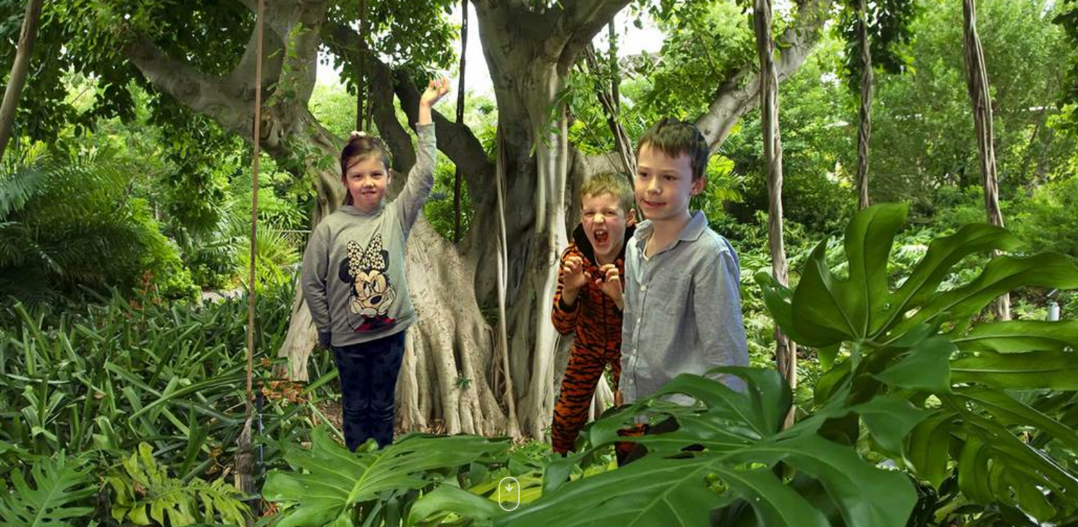
Task 1- Question Time
Look at the picture above and use your imagination to answer the following questions:

A Portkey is a magical object enchanted to instantly bring anyone touching it to a specific location. Most of the time, a Portkey is an everyday object that would not draw the attention of a Muggle.
What does the port-key look like?
……………………………………………………………………………………………
Where might they have been on previous adventures?
………………………………………………………………………………………………
How do you think they return home after an adventure?
………………………………………………………………………………………………
Where did they get the port-key from?
………………………………………………………………………………………………
If you could go on an adventure somewhere, where would you like to go?
………………………………………………………………………………………………
Where would you least like to go on an adventure?
………………………………………………………………………………………………

Task 2- Sentence challenge
These sentences are ‘sick’ and need your help to get better. Can you help?
The girl held the port-key. There was a bang and some smoke. The children landed in the jungle. It was hot. They were scared.
………………………………………………………………………………………………………………………………………………………………………………………………………………………………………………………………………………………………………………………………………………………………………………………………………………………………

]Task 3- Grammar/punctuation challenge
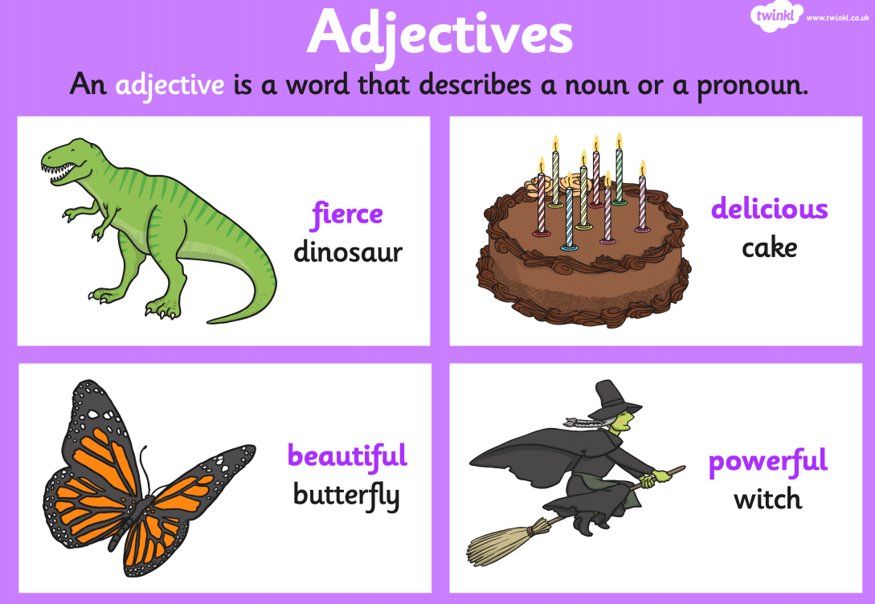

Using some adventurous adjectives, can you write a description of what it would be like to be in a jungle?
You could think about using your senses, for example, thinking about what sounds you might hear around you.
You could also describe how you might be feeling.
…………………………………………………………………………………………………………………………………………………………………………………………………………………………………………………………………………………………………………………………………………………………………………………………………………………………………………………………………………………………………………………………………………………………………….....…………………………………………………………………………………………………………………………………………………………………………………………………………………..

Task 4- Story starter!
Moments earlier, she had been standing in her classroom holding the tiny port-key up in her hand, waiting for the magic to happen. With a flash and a puff of smoke they had vanished into thin air.
The port-key had taken them to some strange places before, but never to a jungle. The problem with port-keys is that you never quite know where you’re going to end up!
They gazed around them and took in their surroundings; the stifling heat and cacophony of jungle noises put the children on edge - they would have to be exceptionally brave on this particular adventure...

Can you continue the story?
…………………………………………………………………………………………………………………………………………………………………………………………………………………………………………………………………………………………………………………………………………………………………………………………………………………………………………………………………………………………………………………………………………………………………….....…………………………………………………………………………………………………………………………………………………………………………………………………………………………………………………………………………………………………………………………………………………………………………………………………………………………………………………………………………………………………………………………………………………………………….....…………………………………………………………………………………………………………………………………………………………………………………………………………………………………………………………………………………………………………………………………………………………………………………………………………………………………………………………………………………………………………………………………………………………………….....…………………………………………………………………………………………………………………………………………………………………………………………………………………………………………………………………………………………………………………………………………………………………………………………………………………………………………………………………………………………………………………………………………………………………….....…………………………………………………………………………………………………………………………………………………………………………………………………………………………………………………………………………………………………………………………………………………………………………………………………………………………………………………………………………………………………………………………………………………………………….....…………………………………………………………………………………………………………………………………………………………………………………………………………………………………………………………………………………………………………

Task 5- Picture it
Can you draw a picture of the children travelling to the jungle using the port-key?

