I can observe how day length varies.

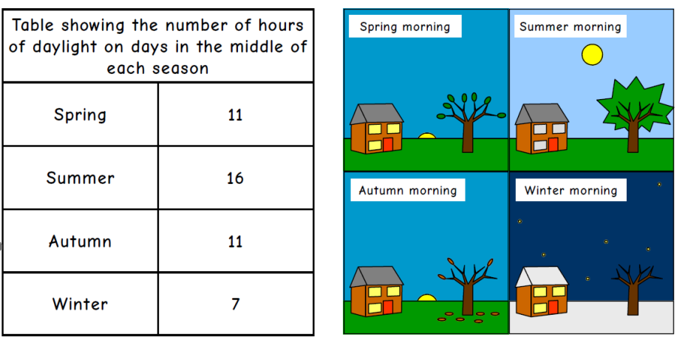
Table
Use the information in the table to help you to create a pictogram showing how many hours of daylight we get in different seasons.
8
14
16
11
Pictogram

