RE- WEEK 1
Who is Muhammad?

- Write down on a piece of paper times when you felt it is good to be peaceful.
Why are these times necessary? Justify ideas.

- What does peace and quiet enable us to do? Have you ever sat alone to think?

- The prophet Muhammad often spent time alone in quiet contemplation. Try to sit quietly and reflect on times when you have been asked to do something that you felt a bit afraid of doing. Share how you felt and what you thought about.

- Go into the website below and watch the video

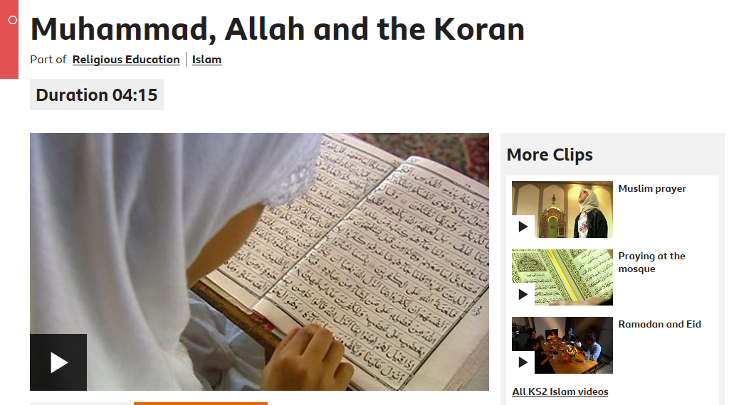

https://www.bbc.co.uk/bitesize/clips/z9b9jxs

- Think about how Muhammad might have felt in the stillness of the cave and compare this to your own ideas from earlier….

- What does peace mean to you? Draw a picture of what this looks like.

