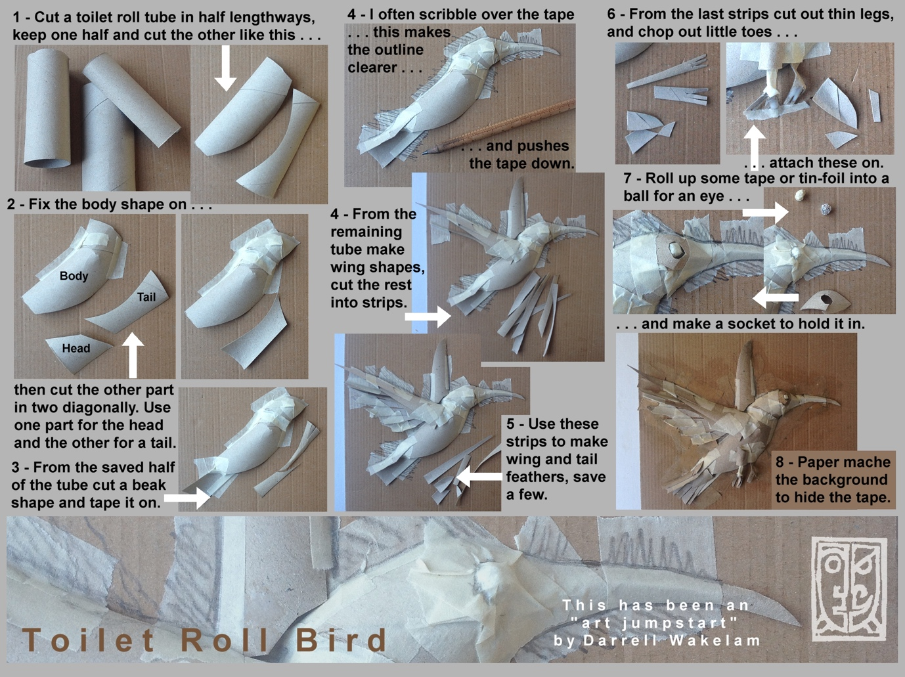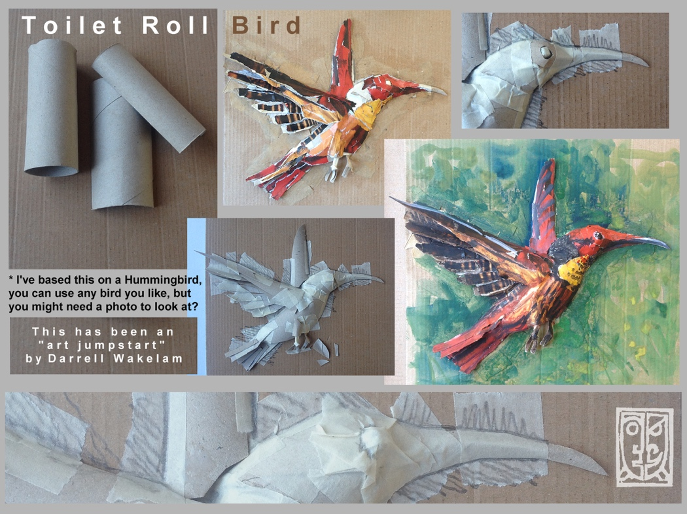

After exploring different animals that are found in the rainforest, you may want to create your own one!

All of the art projects below, can be made using different ‘junk materials’ at home!

This is optional so please don’t feel like you have to!

As you can see from the photos below, they are simple yet effective!

