Name-___________________Date-__________

half past

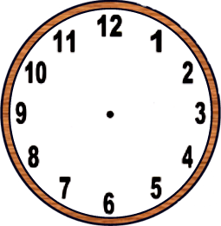

 | half past 9 |  | half past 7

 | half past 11 |  | half past 2

 | half past 6 |  | half past 1

 | half past 8 |  | half past 3

 | half past 5 |  | half past 12
Name-___________________Date-__________

half past

 | half past two |  | half past nine

 | half past three |  | half past five

 | half past one |  | half past ten

 | half past four |  | half past eight

 | half past six |  | half past eleven
Name-___________________Date-__________
half past

 | half past 1 |  | half past 4

 | half past 8 |  | half past 6

 | half past 2 |  | half past 7

 | half past 5 |  | half past 10

