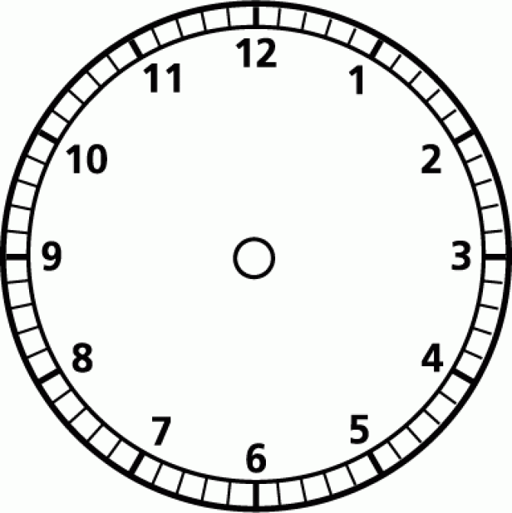
When it is o’clock When it is half past When it is quarter past

the minute hand points to the minute hand points to the minute hand points to

¼ past 12 ¼ past eight

¼ past 7

quarter past 1 quarter past eleven

When it is half past When it is qurter past When it is quarter to

the minute hand points to the minute hand points to the minute hand points to

¼ to 12 ¼ to eight

¼ to 2

quarter to 1 quarter to five

