

***LEARNING FROM HOME***

***YEAR 1 – Week Beginning 08.06.20***

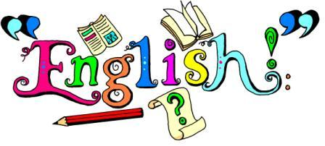

* Please download Studybugs if you haven’t already done so, so you can receive school updates and messages.
* **Phonics**- Draw and name 2 aliens each day. Each alien name should include phonic sounds that you know and can read using **Special Friends, Fred Talk, Say the word.** Look at the alien words in the phonics folder to get some ideas.
* **English**- <https://www.youtube.com/watch?v=E-wbxz8Drjw>
* Watch the story ‘The Queen’s Knickers’ and use the template in the writing folder or a piece of paper to design a pair of knickers. Use describing words to write some sentences about it.
* **Grammar**- Complete the adjective activities in the grammar folder.

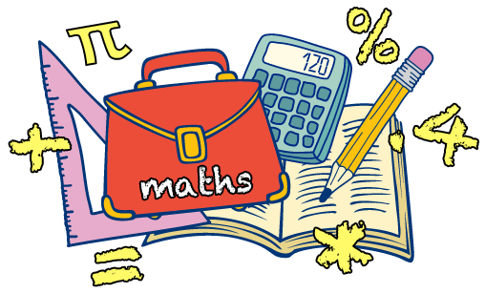

* We have learnt our number bonds to 10. This week we will be recapping them using the work sheets in the maths folder.

<https://www.youtube.com/watch?v=lD9tjBUiXs0>

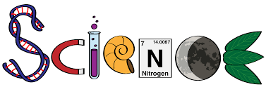

Seasonal changes

* This week we are going to learn about seasonal changes especially between Spring and Summer. Use the search engine ‘Kiddle’ to find out more about it.
* Draw the change in weather from Spring to Summer. Create a poster to compare the different weather in both of these seasons. You can email your pictures to your teachers.



**History:** Our History topic is ‘Queen Elizabeth I and Queen Elizabeth II. This week write a list of questions to ask Queen Elizabeth I. You could create a poster or do some drama with a member of your family and pretend to ask them questions.

**RE:** This term we will be learning about ‘Hinduism’. This week explore the different Hindu Gods and Goddesses. Learn about the different Gods and Goddesses from the fact file cards in the RE folder, and compete the word search.

**Computing**: Purple Mash: Use your log-in to explore all the games available. Explore 2Paint.

**D&T:** We are learning about different fruit and vegetables. This week your challenge is to make sure you eat 5 different fruits or vegetables each day. Try something you have never eaten before.

**A time for us:** This week we are labelling parts of the body. Use the interactive activity to label body parts correctly. <https://www.twinkl.co.uk/go/resource/tg-sc-05-parts-of-the-body-labelling-activity>

Additional Activities/suggestions –**You can email your completed work to ks1@northbeckton.ttlt.academy**

Go on a treasure hunt. Find 10 items that are round. Find 10 items that are square. Find 10 items that are red. Find 10 items that are green.