How to play the game
- Open the file called GAME, you should see this:
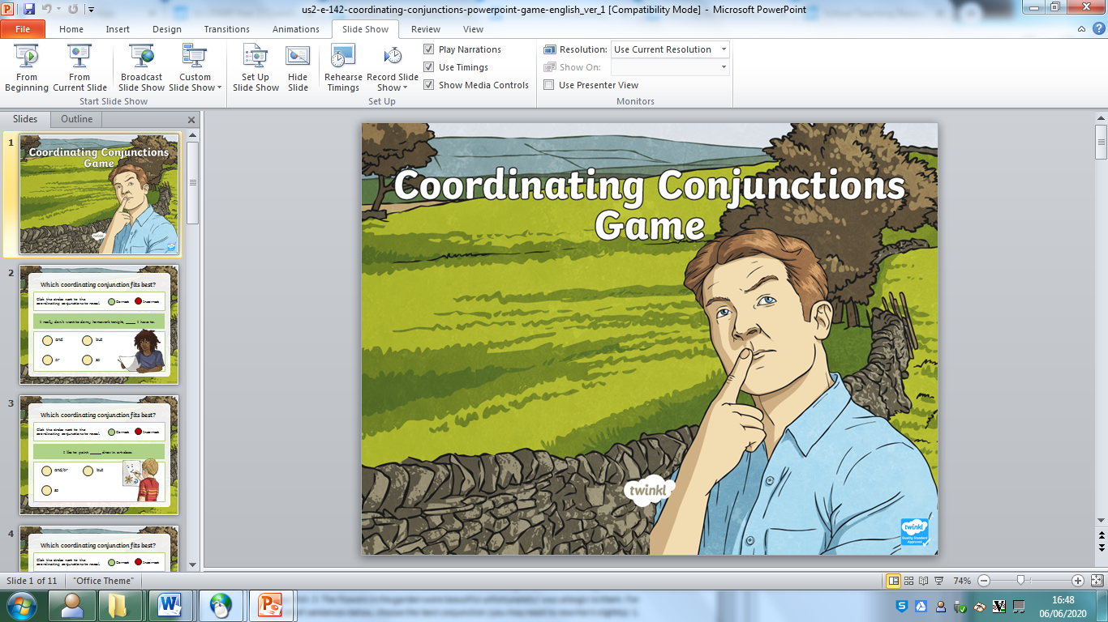

- Click on the “Slide Show” Icon in the bottom right corner:

- On your screen you should see only this:
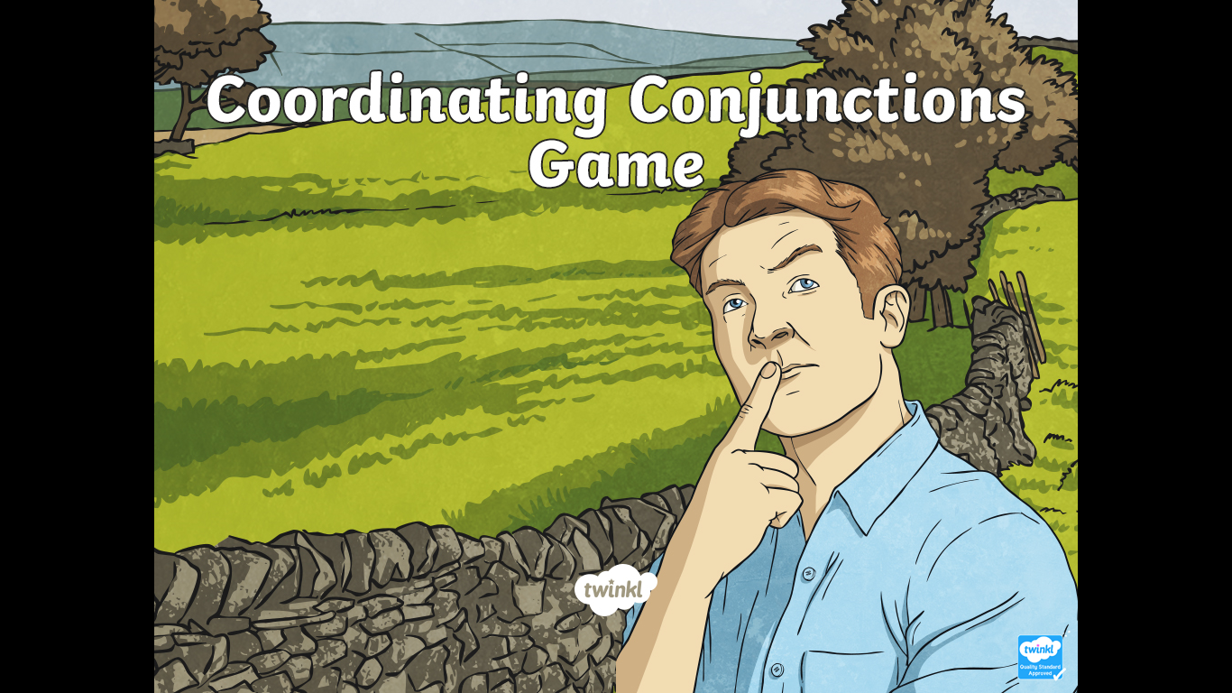

- Have fun

