LO: To understand the different ways in which seeds disperse

Picture of the seed | Name of plant the seed came from | Method of seed dispersal and reasons why
Example:  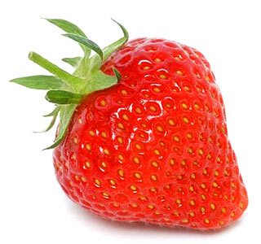 | Strawberry Plant | I think the seeds are eaten by animals and then dispersed when they are excreted because the seeds are surrounded by delicious fleshy red fruit.

