FUN WAYS OF WRITING

Writing

- Make letters with play dough. (Initially, make the letter on top of a large printed letter).

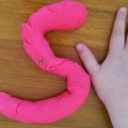

- Practice letter shapes using shaving foam, gloop, sand, finger paint and sand paper
