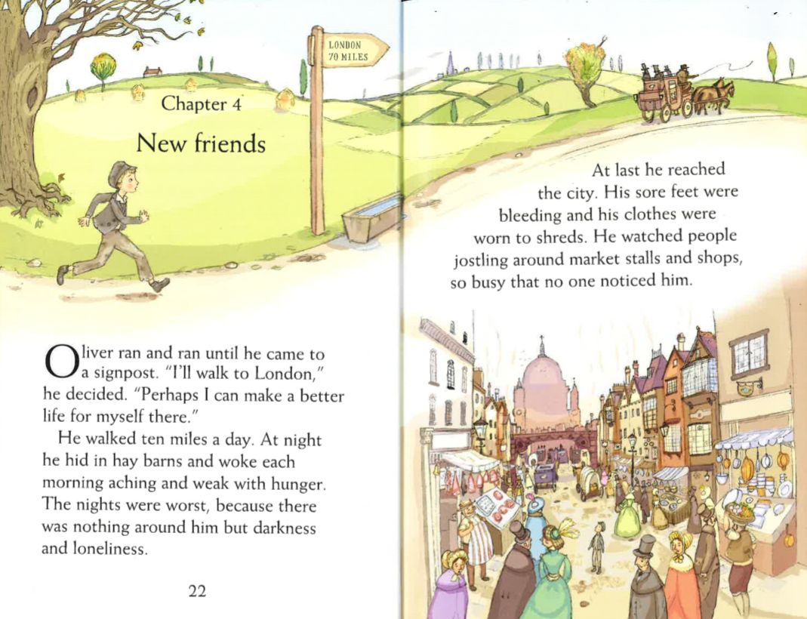
Questions
Summarise what has happened in the book so far in 10 points

How many miles a day did Oliver walk?

How do you think Oliver felt when he was travelling to London? Why?

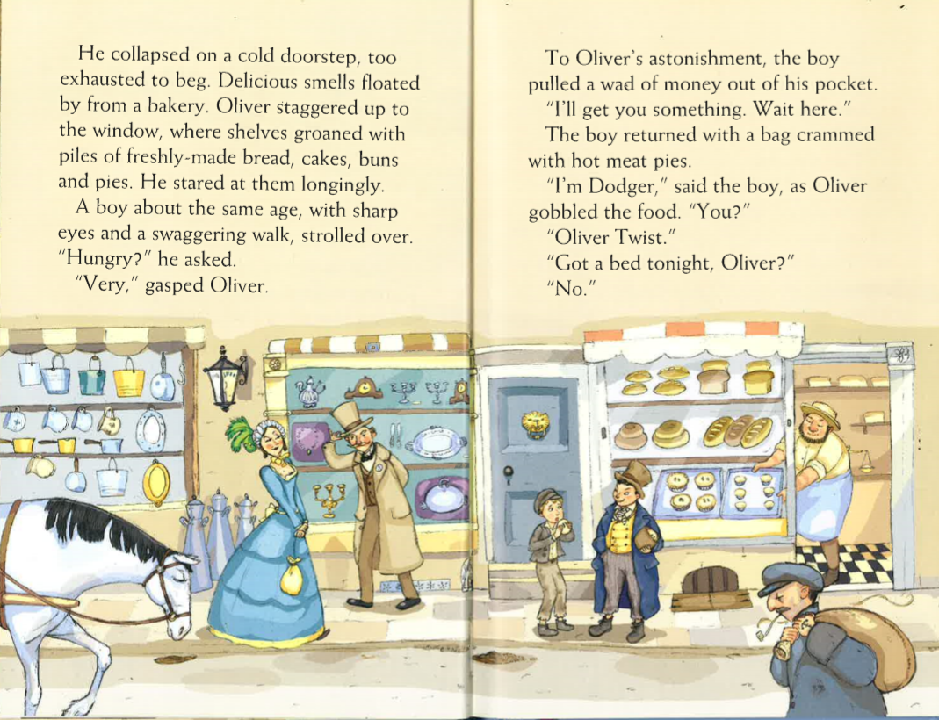
Questions
Find and copy two things Oliver could see in the bakery window?

Why did Oliver stare at the Bakery objects “longingly”?

What is the name of the boy Oliver met?

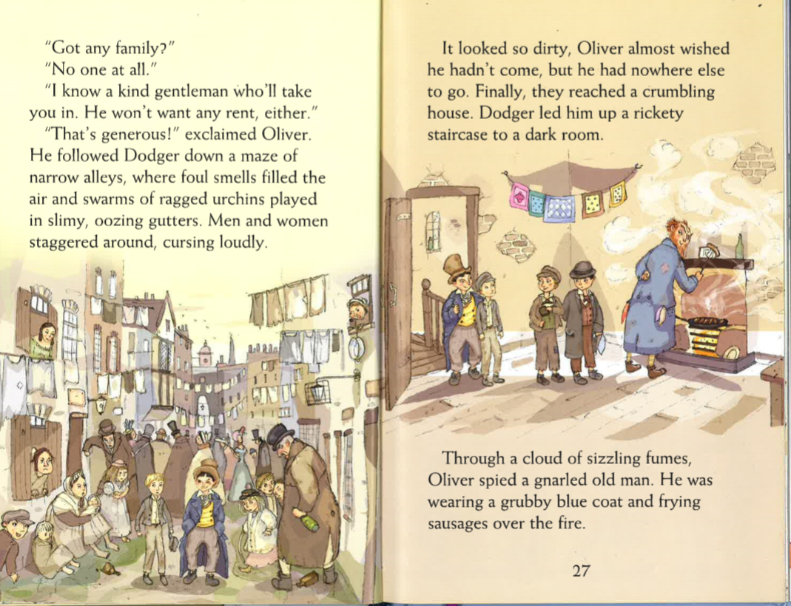
Questions
What does the word “urchin” mean?

What does the word “gnarled” mean?

Find and copy two things Oliver saw when Dodger took him down the alleys.

Do you think Oliver made the right decision to go with Dodger?

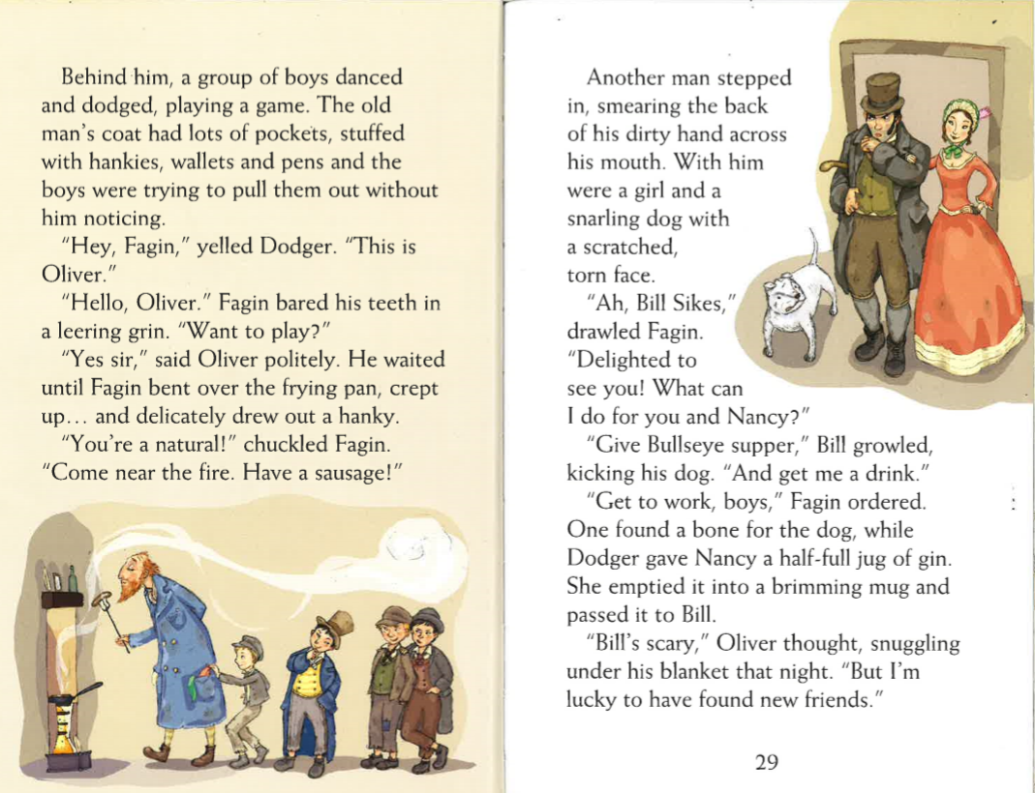
Questions
Why were the boys trying to pull things out of Fagin’s pockets?

What did Dodger give to Nancy?

What two things did Bill Sykes want from Fagin?

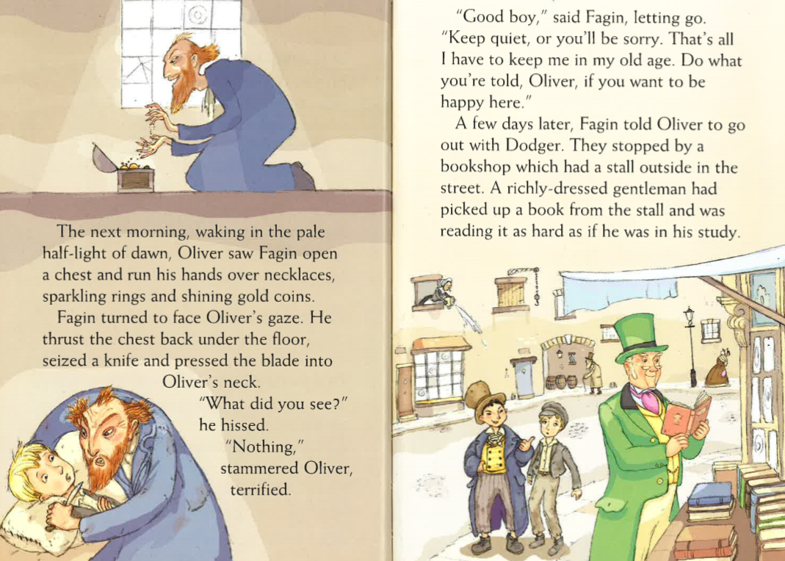
Questions
What was in Fagin’s chest?

Why did Fagin ask Oliver to keep the chest a secret?

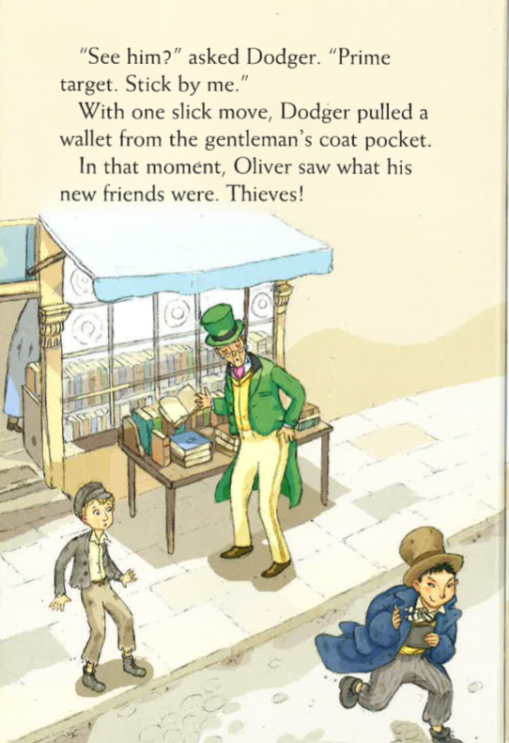
Questions
What did Dodger pull form the man’s pocket?

How do you think Oliver felt when he realised what his friends were?

Predict what is going to happen next.

