Islam

What are Muslims?
Muslims are the followers of the religion of Islam. The word Islam comes from an Arabic word meaning submission. A Muslim is a person who has submitted to God (Allah).
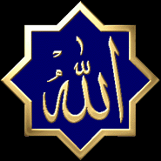Allah written in Arabic

What do Muslims believe?
Muslims believe there is only one God. In Arabic the name for God is Allah.
Muslims also have the following beliefs:
- Belief in angels
- Belief in the holy books – The Quraan, The Bible (Injeel), The Torah (Toraat) and The Psalms (Zaboor)
- Belief in the Prophets (special messengers)
- Belief in the Day of Judgement – A day when Allah will decide who will go to heaven or who will go to hell.
- Belief in life after death

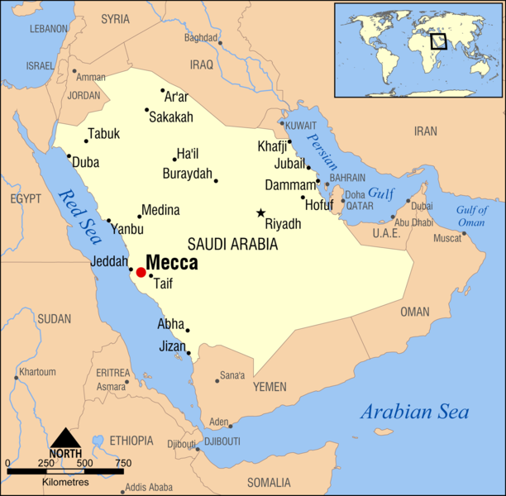
Who is Mohammed?
The prophet Mohammad, peace be upon him, who was born in A.D. 570 at Mecca, in Saudi Arabia. Mohammed is not Allah. He was the last prophet to be sent by Allah. However the first prophet was Adam, peace be upon him. Mohammed’s father died before he was born and his mother died when he was only six years old. Mohammed, peace be upon him, was well known for his honesty and goodness.
The Angel Gabriel (Jibreel) came to Mohammed and told him he was a prophet of Allah. Mohammed, peace be upon him, started to preach about Islam, a few people believed him. The Muslims began being persecuted, tortured and hurt and they were forced to leave Mecca. Mohammed, peace be upon him, and the other Muslims left Mecca and went to Madina. The people of Madina believed in the prophet Mohammed, peace be upon him, and Islam started to spread from Madina.

There were many prophets before Mohammad, peace be upon him, including: Adam, Noah (Nuh), Abraham (Ibraheem), Ishmael (Ismaeel), Isaac (Ishaq), Jacob (Yacoub), Joseph (Yousef), Moses (Musa), David (Daood), Solomon (Sulaymaan), Jonah (Younas), John the Baptist (Yahya), and Jesus Christ (Isa), peace be upon all of them.

Whenever Muslims mention the names of prophets, they always say ‘peace be upon them’.

What should Muslims do?
Muslims should follow the Quraan. The Quraan is Allah’s word and it was given to Mohammed, peace be upon him. The Quraan was revealed to Mohammed, peace be upon him, over a period of 23 years through revelation. The revelation would come from Allah.
In the Quraan, Allah says that he sent the prophet Mohammed, peace be upon him, to guide mankind. Mohammed, peace be upon him, is a role model for Muslims. The way the prophet lived his life is an example of the life Allah wants people to live. The way the prophet lived and the kind of things he did is called Sunnah. What Mohammed, peace be upon him, said is called Hadith.

Muslim’s lives are therefore guided by the Quraan, the Sunnah and Hadith.

The Five Pillars of Islam

What are the five Pillars of Islam?
The five pillars are the most important forms of worshipping Allah. Every Muslim must do the following.
- Shahadat
- Salah
- Zakah
- Fasting
- Hajj

What is Shahadat?
Shahadat is declaring your faith.
"I bear witness that there is no god, but Allah and Muhammad is the prophet of Allah."
By saying this and believing it in your heart, a person becomes a Muslim.
In Arabic the Shahadat is said like this:
LA ILAHA ILLALLAH, MUHAMMADUR RASOOL ALLAH

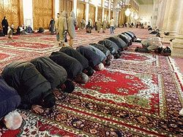
What is Salah?
Salah is praying. Muslims pray five times a day; once in the morning, once at midday, once in the afternoon, once in the early evening and once at night time. Muslims must do the following before praying Salah:

  - They must clean themselves. This is called making Wudhu.
  - They must have clean clothes on.
  - They must pray at a clean place.
  - They must face towards Mecca.
  - They must pray at the correct time.

The Salah is made up of different postures such as standing, bowing, and sitting. During the Salah, Muslims recite prayers in Arabic. One Arabic prayer that is recited during every Salah is a little bit like the Lord’s prayer. Here is the translation:
All praise is for Allah, the Lord of the worlds, the most kind, the most merciful, Master of the Day of Judgement, You alone we worship and You alone we ask for help.
Guide us along the straight path, the path of those whom You rewarded,
not those who earned Your anger, nor those who went astray.
When the Salah is over. Muslims then make a cup shape with their hands and ask what they need from Allah. This is called Dua. At the end of the Dua, Muslims say Ameen (Amen).

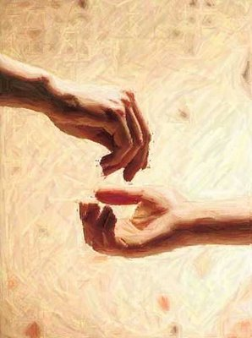
What is Zakah?
The Arabic word Zakah means to purify. Muslims ‘purify’ their wealth through Zakah. Muslims give a minimum of 2.5% of their savings to poor people every year. Muslims who do not give Zakah are not doing their duty and they make Allah angry.
Muslims must earn their money through hard work and not through gambling or through stealing.

What is Fasting?
Fasting (Sawm in Arabic), is done in the month of Ramadan. During Ramadan, Muslims do not eat or drink anything during the hours of daylight. People who are ill, or old, or children do not have to fast during Ramadhan. Muslims try to be very good during the month of Ramadhan because it is a month of blessings from Allah. Fasting reminds Muslims that they must be patient and that their religion is more important to them than even eating and drinking. It also reminds Muslims of the poor and hungry people in the world.

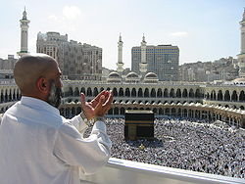
What is Hajj?
Hajj is the pilgrimage (journey for religious reasons) to Mecca. Every Muslim adult must go to Mecca once in a lifetime if they can afford it. Many people save for years to go to Mecca. For Muslims, Mecca is the holiest place on earth.
Every year about three million people go to Mecca. They all gather at the same time. Muslims believe that if they perform Hajj properly then everything they have done wrong in their lives will be forgiven by Allah.

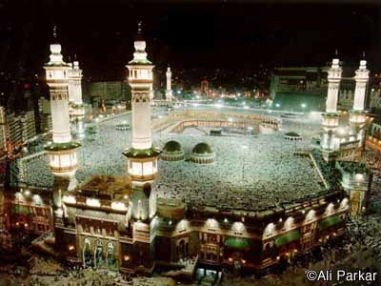 | 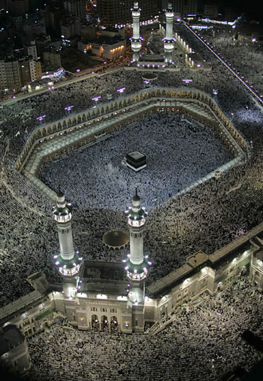
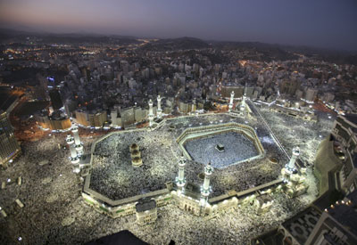
The Grand Mosque in Mecca

Inside the Grand Mosque is the Kaaba. The Kaaba was built by the prophet Abraham (Ibraheem). It was the first place of worship on the earth. Muslims go around the Kaaba seven times. They meditate and read prayers while they go around.
The Hajj is very peaceful. Even though millions of people gather in one place there is never any violence or fighting. Everyone is there for worshipping Allah.
Islamic Artefacts

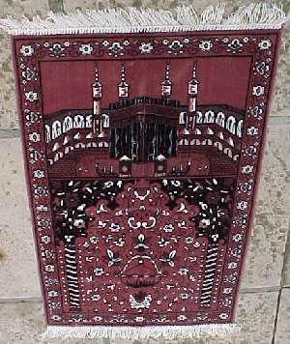
Musallah or Prayer Mat
This is a mat that is used for Salah. The mat is laid down in a clean place and facing Mecca. Muslims take off their shoes before they step onto the mat.

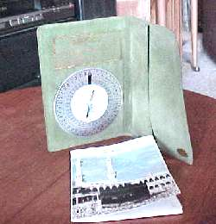
A Compass
A compass is important as Muslims can use this to find the direction of Mecca, before they pray.

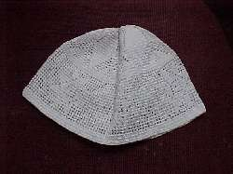
Hat
Muslims men must cover their head with a hat before praying.

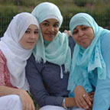
Headscarf (Hijaab)
Muslim women must cover their heads with a Hijaab.

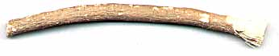
Miswaak
The Miswaak is like a toothbrush, or tooth cleaner. It is used during Wuhdu. It does not need toothpaste and comes from a special tree called Peelu (Salvadora Persica).

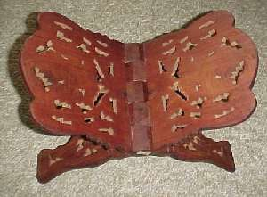
Quraan Stand
The Quraan is put on this stand when it is being read.

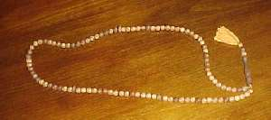
Muslim Prayer Beads
Muslims use beads to help them count when they are meditating. The string has 100 beads on it.

Attar
Attar is fragrance that does not have any alcohol in it as alcohol is considered unclean. Muslims may wear attar to smell nice.

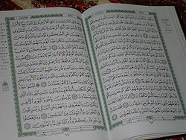
The Quraan
The Quraan is the Holy Book of Islam. It is like the Bible. Muslims believe it is the word of Allah. They treat it very carefully and with respect. Muslims will not touch the Quraan unless they have cleaned themselves first.

The Holy Quraan – The Holy Book of Islam

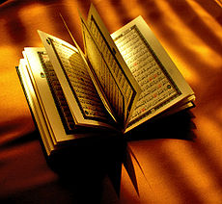
Muslims believe the words of the Quraan are the words of Allah (God). They were given to Mohammed, peace be upon him, by the Angel Jibreel (Gabriel). The Quraan is written in Arabic. Arabic is written from right to left.
Muslims believe the words of the Quraan should not be changed in any way. All Muslims can recite parts of the Quraan. Some Muslims can recite the whole of the Quraan by heart.
Children learn to read the Quraan at home, or by going to the Mosque after school. The Quraan is treated with a great deal of respect and it is usually wrapped in a clean cloth. A Muslim will not touch the Quraan without making Wudhu first.
The Quraan has 114 chapters. The Quraan says that Mohammed is not the only prophet that Allah sent down, but that Jesus (Isa) was a prophet, Abraham (Ibraheem) was a prophet, Moses (Musa) was a prophet, Noah (Nuh) was a propet, David (Daud) was a prophet, Joseph (Yousef) was a prophet and Solomon (Sullemaan) was a prophet – peace be upon all of them.
The Quraan explains how Muslims should live their lives. The Quraan explains that Mohammed, peace be upon him, was the final prophet. If a person follows the example set by Mohammed, peace be upon him, then they will be successful and get to Paradise (Jannah). The Quraan also warns a person not to do bad things or follow the Devil (Shaitaan) or else Allah will be angry.

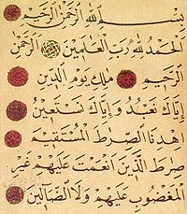 The opening verse of the Holy Quraan
The Mosque

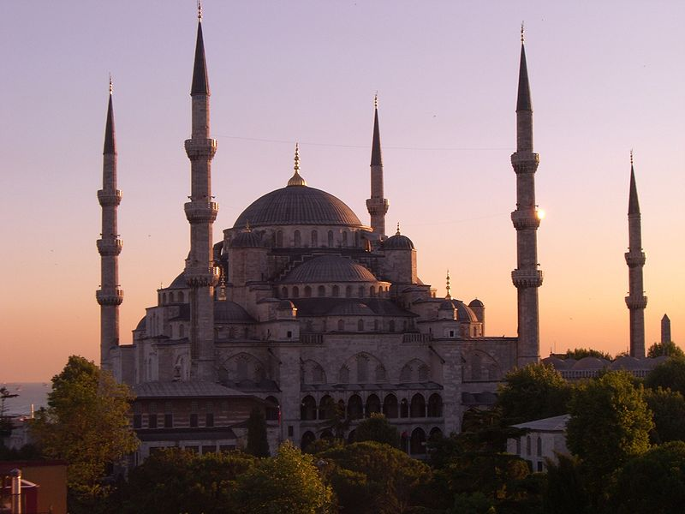
Where do Muslims worship?
Muslims can pray anywhere that is clean, but the best place to pray is in a mosque. Muslims often refer to the mosque by its Arabic name, Masjid. The word comes from the Arabic for "place of prostration".
Muslims are called to prayer. The man who calls people to prayer is called a muezzin. The muezzin calls the Muslims to pray with a special prayer called Azaan.
In Britain, calling Muslims to pray this way is not allowed, so some mosques broadcast the call to prayer, like a radio, which Muslims can pick up in their homes.
There are no pictures or statues in a mosque. They are decorated with patterns and words from the Quraan. There is also very little furniture inside because Muslims use prayer mats for prayer.
When people go into the mosque they take off their shoes. This is to keep it clean for prayer. There is a washing area where people can make Wudhu. All mosques face towards Mecca. Women do not pray in the same place as men, either they pray at home, or there is usually a screened off area for them.
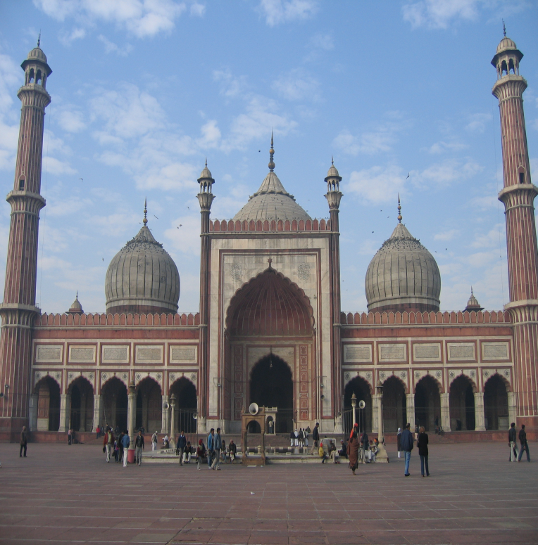
Ramadhan

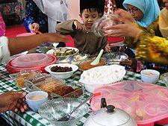
Ramadhan is the ninth month in the Islamic calendar. During Ramadhan, Muslims across the world will fast (do not eat) during the hours of daylight.
The Muslim year is a lunar (moon) year, so Ramadan moves forward by ten or eleven days each year. The day Ramadan begins is decided by the sighting of the new moon.
Muslims believe that the gates of Heaven (Jannah) are open and the gates of Hell (Jahanam) are locked during Ramadan.
Ramadhan is very special because the Quraan was revealed to the Prophet Muhammad, peace be upon him, during this month. Ramadan is a time of worshipping Allah. Every Muslim is expected to fast from sunrise to sunset. Muslims must not eat or drink during daylight hours. During Ramadan Muslims get up early before dawn (Fajr) and have a light meal. This time is known as Suhoor.
At the end of each day (Maghrib), Muslims break their fast with a meal called the iftar. The fast is often broken with dates, then followed by a prayer and dinner.

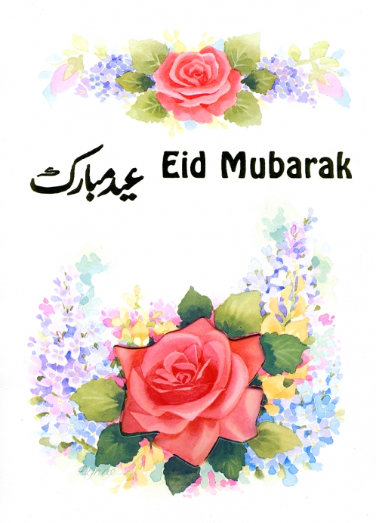
At the end of Ramadan there is a celebration called Eid-ul-Fitr. Everyone dresses in their best clothes. They go to the mosque to pray together. Special celebration meals are served up. Everyone has a holiday and many big family groups of relations all get together. Children are given sweets, presents and often new clothes. Muslims send cards to each other to celebrate this special time. They often make offerings to the poor and sometimes buy each other presents.

Islam in the Home

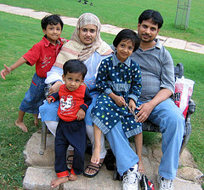
The Ummah
Muslims regard all followers of Islam as belonging to one big family called the Ummah. The idea of Ummah is very important and helps explain why Muslims are so concerned about other Muslims around the world.

The Quraan says that respect for your parents is very important. Elderly relatives are treated with great respect. In a Muslim home you may find grandparents living with the rest of the family. Muslims find the idea of homes for elderly people quite shocking.

Food
Islam teaches that some foods are allowed and some foods are not. The Quraan forbids Muslims from eating Haraam (forbidden) food and to only eat Halal (allowed) food. Meat of an animal that eats another animal is Haraam. Pig and pork products are Haraam. Other animals such as chicken and sheep can be eaten, but they must be killed in a Halal manner. A prayer is read whilst the animal is being killed. Muslims are also not allowed to drink alcohol. Alcohol is also Haraam.

Islamic Art

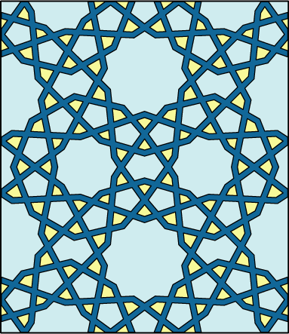
Most Muslim families will have religious pictures on the wall, but pictures showing people or animals are not used. Muslims do not worship any images or statues. They take great care to worship Allah only, who has no image.

Islamic art is very beautiful and has geometric patterns that repeat. Some are very complicated.

