Science: Animals including Humans
Gestation
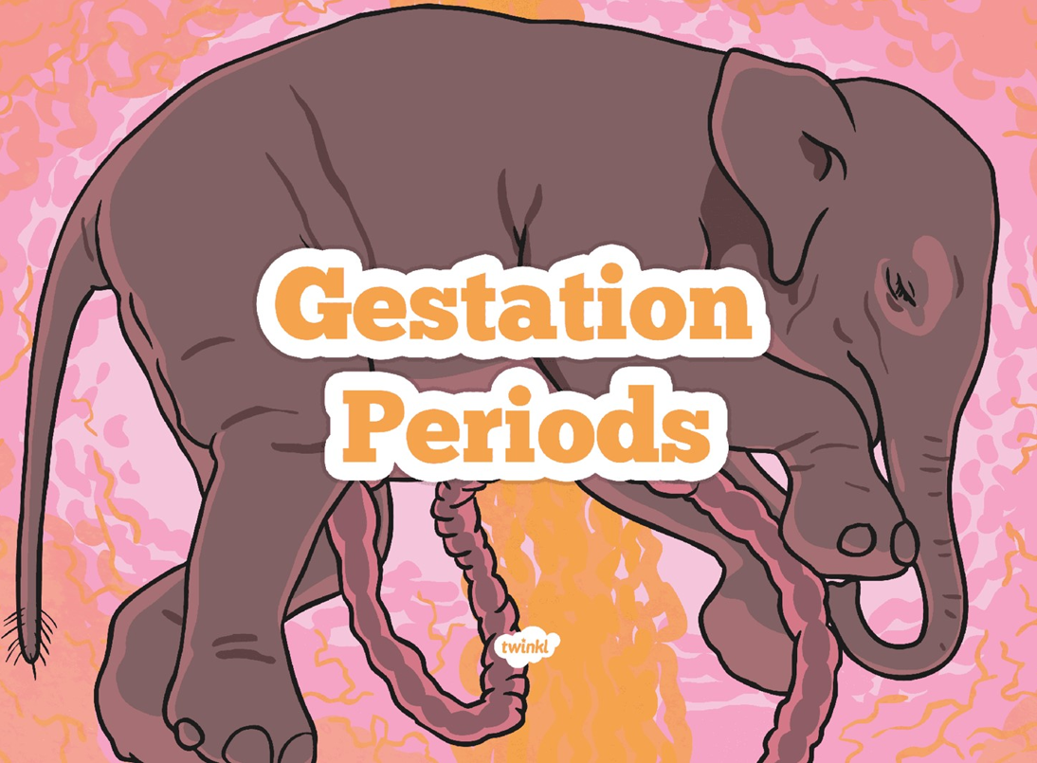
TASK 1- What is gestation?
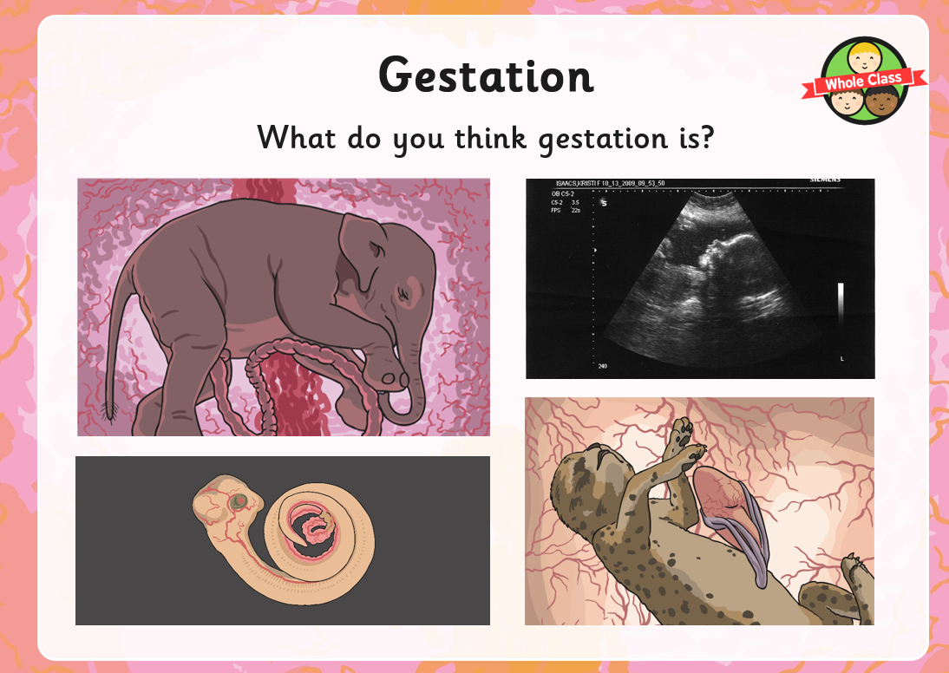

…………………………………………………………………………………………………………………………………………………………………………………………
…………………………………………………………………………………………………………………………………………………………………………………………
………………………………………………………………………………………………………………………………………………………………………………………….

Gestation is the period of time that a mammal carries her offspring, or babies, inside her body before giving birth.
TASK 2- Sorting animals’ gestation periods
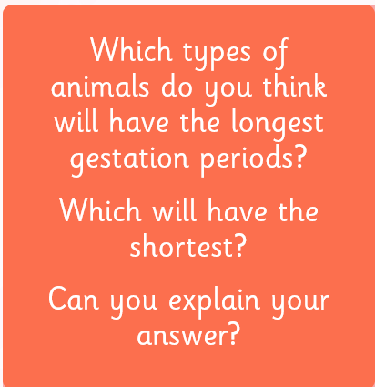

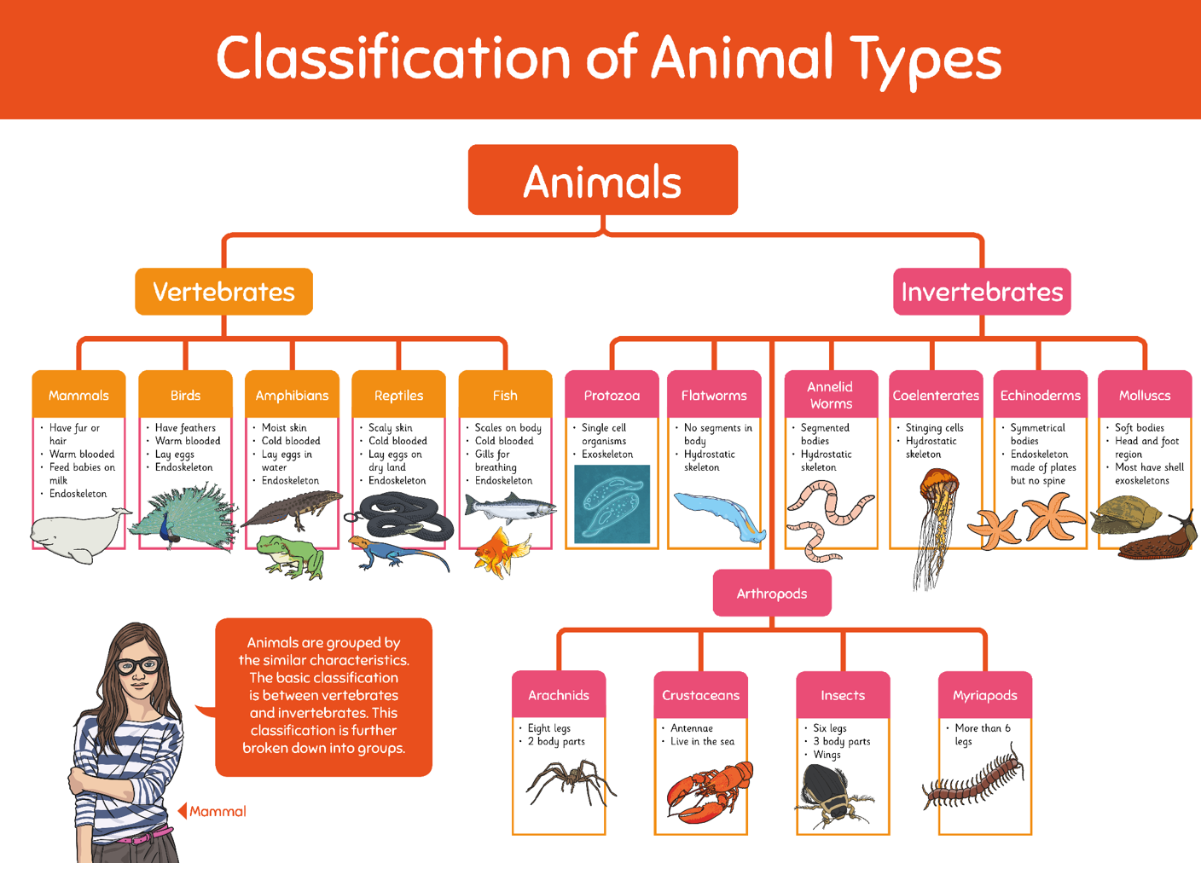

………………………………………………………………………………………………………………………………………………………….....................................
……………………………………………………………………………………………………………………………………………………………...................................
……………………………………………………………………………………………………………………………………………………………...................................
……………………………………………………………………………………………………………………………………………………………...................................

TASK 3- Prediction
Use the Classification of Animal Types Poster above to help you with your task.
You will be comparing different groups of vertebrates.
Prediction: Predict the length of time of gestation for the following animals.
Order the animals on the line from the shortest gestation period to the longest. Under the name of the animal write the type of animal they are (i.e. mammal, fish). Animals: Human, frog, goldfish, snake, whale, parrot, salmon, lizard.

SCROLL DOWN TO THE NEXT PAGE FOR THE ANSWERS

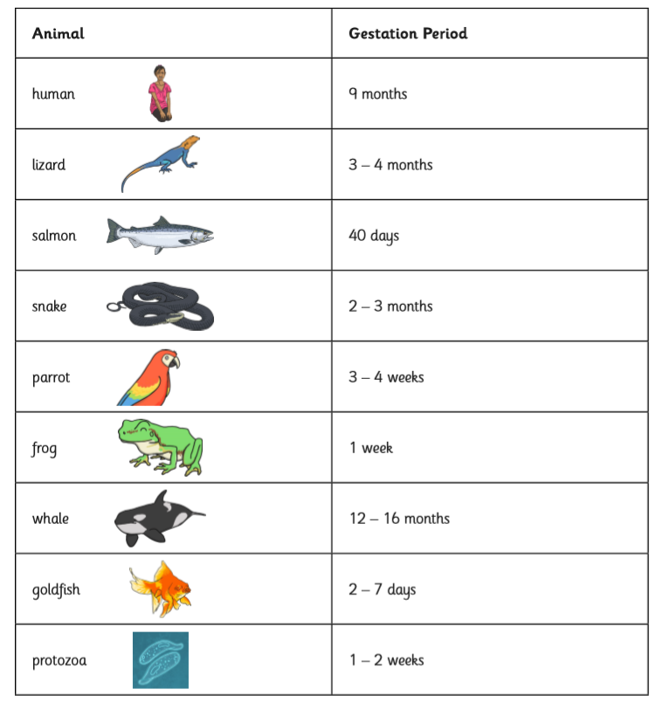
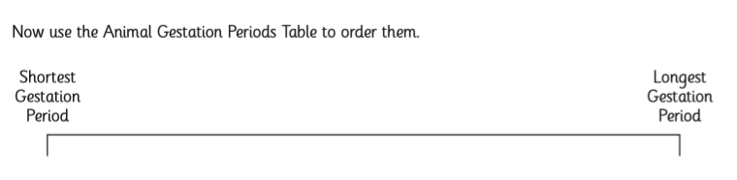

Were your predictions correct?
…………………………………………………………………………………………………………………………………………………….
…………………………………………………………………………………………………………………………………………………...

TASK 4- Is this statement correct?

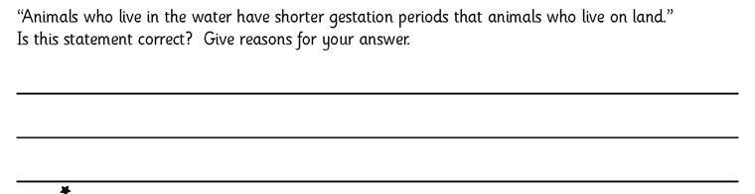

TASK 5- Information booklet

Follow the template below to create an information booklet on ‘Gestational Periods’

