Art – Portraits
4.5.20
Self-portrait drawing practise
Last week we practised drawing people in the house using photographs or getting them to sit for a while, as promised, I had a go too! Hopefully, some of you were also inspired to make a sketch book. This week we’re going to ‘build’ on our portrait drawing skills.
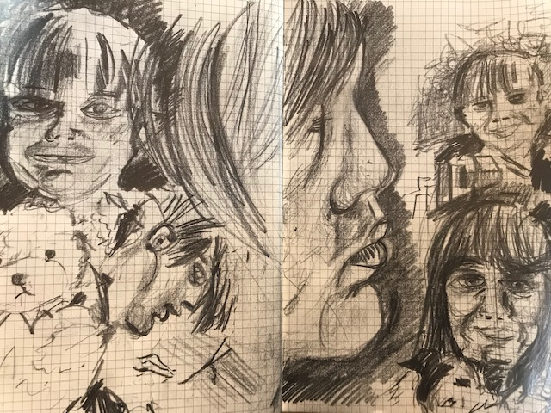 last week

Part 1
Working from a mirror, or using an IPad to photograph yourself first , draw four or five self-portraits at different times of the day. Look at the areas of light and dark, think about how something as simple as the time of day can change the image. Do you need more or less dark areas depending on what the time is? Use whatever materials you have to hand, even if it’s only a pencil or pen. Remember to think about making different kinds of marks when drawing, have a look at this video. You don’t have to, but you could try this technique.
https://www.youtube.com/watch?v=MT8hP6ovzTI

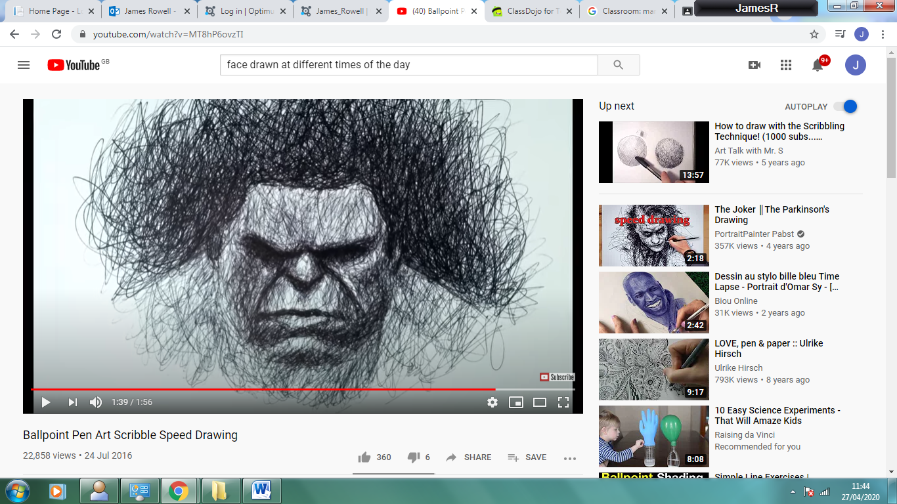
Another idea.
https://www.youtube.com/watch?v=lmUrxx0hdv4
This person draws the whole face at the same time by gradually building up the image using a blunt pencil.
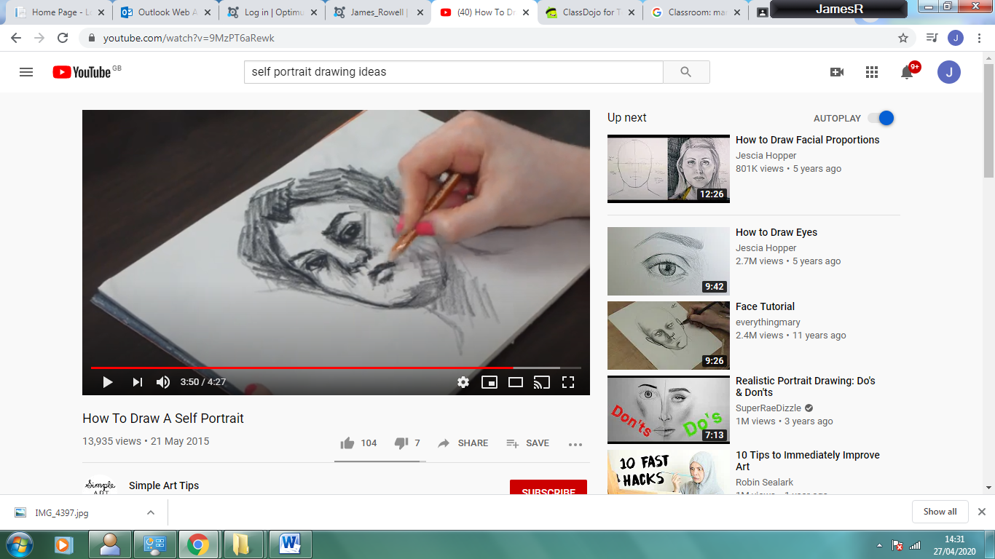
https://www.youtube.com/watch?v=9MzPT6aRewk

You don’t have to produce a finished piece of work yet. Very similar to last week, your work should be a series of self-portrait practises, done however you like on a page or pages.

Part 2 - Challenge:
Additionally, think about item(s) that have meaning to you could you include any in your portrait practises?
What feeling or mood should your portrait ideas have? Can you express these through your drawings?

