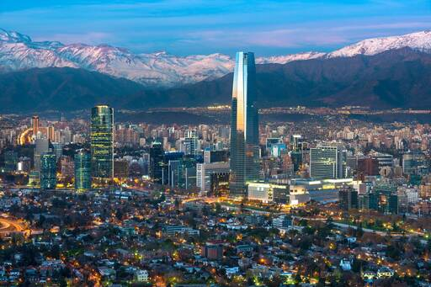

Before half term, we explored Brazil. We investigated what the country was like, as well as finding out many fun facts along the way! This week we will be exploring Chile. You will carry out a similar task to Brazil but this time while you are researching, I would like you to try and make comparisons to Brazil.

What does Brazil and Chile have in common as a country? Do they eat some of the same cuisine? Is there a similar climate or similar population?

What is different about Chile to Brazil? IS Chile famous for anything in particular?

You can present your information any way you wish. You could write a report in your home learning book, or create a double page spread with illustrations and diagrams or you could create a Google Slides presentation. Although I must admit, I would love to see a double page (if you could send in pictures)!

Things to include:

* Where Chile is
* Capital City
* Population
* Similarities and differences between Chile and Brazil
* Diagrams/ statistics
* Fun facts
* Anything else you want to include!

If you are unsure about anything or have any questions you can send a message through Google Classroom or send an email to [UKS2@northbeckton.ttlt.academy](mailto:UKS2@northbeckton.ttlt.academy)