FINGERPRINT BLOSSOM TREE
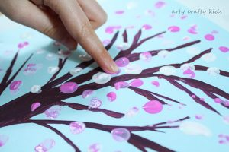
Simply paint a tree onto the paper or card. You could use a twig to do this.
Or, to add a personal touch, draw around your child’s hand and arm to create a ‘handprint tree.
Using a mixture of pink and white paint, encourage your child to dip their fingers into the paint and create prints all over the tree.
The blossom could be on the floor, over the bark or floating in mid-air.
There’s no right or wrong!

