Time for Us- Sleep
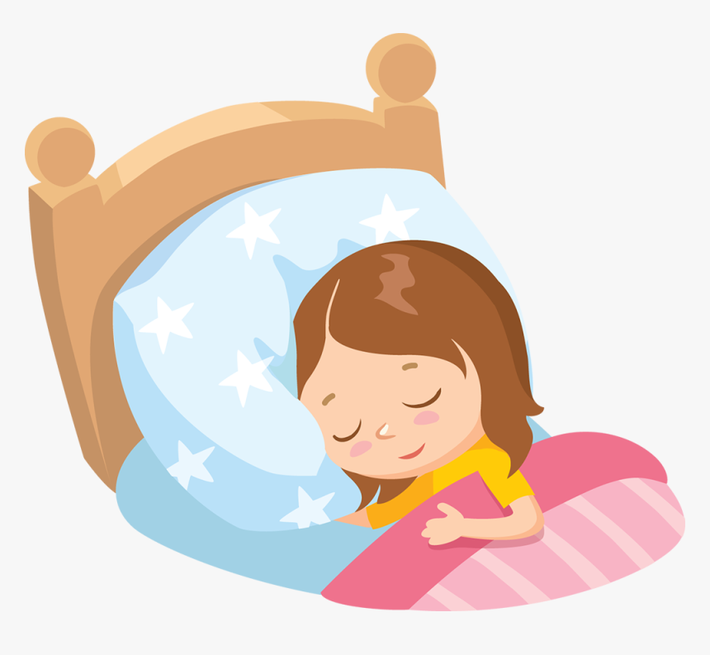
Sleep is more important than you may think. Can you think of a time when you didn't get enough sleep? That heavy, groggy feeling is awful and, when you feel that way, you're not at your best. So if you're not too tired, let's talk about sleep.

Why You Need Sleep
The average kid has a busy day. There's school, taking care of your pets, running around with friends, going to sports practice or other activities, and doing your homework. By the end of the day, your body needs a break. Sleep allows your body to rest for the next day.
Everything that's alive needs sleep to survive. Even your dog or cat curls up for naps. Animals sleep for the same reason you do — to give your body a tiny vacation.

Your Brain Needs Zzzzzs
Your body and your brain need sleep. Though no one is exactly sure what work the brain does when you're sleeping, some scientists think that the brain sorts through and stores information, replaces chemicals, and solves problems while you snooze.
Most kids between 5 and 12 get about 9.5 hours a night, but experts agree that most need 10 or 11 hours each night. Sleep is an individual thing and some kids need more than others.
When your body doesn't have enough hours to rest, you may feel tired or cranky, or you may be unable to think clearly. You might have a hard time following directions, or you might have an argument with a friend over something really stupid. A school assignment that's normally easy may feel impossible, or you may feel clumsy playing your favorite sport or instrument.
One more reason to get enough sleep: If you don't, you may not grow as well. That's right, researchers believe too little sleep can affect growth and your immune system — which keeps you from getting sick.

The Stages of Sleep
As you're drifting off to sleep, it doesn't seem like much is happening . . . the room is getting fuzzy and your eyelids feel heavier and heavier. But what happens next? A lot!
Your brain swings into action, telling your body how to sleep. As you slowly fall asleep, you begin to enter the five different stages of sleep:

Stage 1
In this stage of light sleep, your body starts to feel a bit drowsy. You can still be woken up easily during this stage. For example, if your sister pokes you or you hear a car horn outside, you'll probably wake up right away.

Stage 2
After a little while, you enter stage 2, which is a slightly deeper sleep. Your brain gives the signal to your muscles to relax. It also tells your heart to beat a little slower and your breathing to slow down. Even your body temperature drops a bit.

Stage 3
When you're in this stage, you're in an even deeper sleep, also called slow-wave sleep. Your brain sends a message to your blood pressure to get lower. Your body isn't sensitive to the temperature of the air around you, which means that you won't notice if it's a little hot or cold in your room. It's much harder to be awakened when you're in this stage, but some people may sleepwalk or talk in their sleep at this point.

Stage 4
This is the deepest sleep yet and is also considered slow-wave sleep. It's very hard to wake up from this stage of sleep, and if you do wake up, you're sure to be out of it and confused for at least a few minutes. Like they do in stage 3, some people may sleepwalk or talk in their sleep when going from stage 4 to a lighter stage of sleep.

R.E.M.
R.E.M. stands for rapid eye movement. Even though the muscles in the rest of your body are totally relaxed, your eyes move back and forth very quickly beneath your eyelids. The R.E.M. stage is when your heart beats faster and your breathing is less regular. This is also the stage when people dream!
While you're asleep, you repeat stages 2, 3, 4, and R.E.M. about every 90 minutes until you wake up in the morning. For most kids, that's about four or five times a night. Who said sleep was boring?

Dream a Little Dream
You're walking down the street and you pass a monkey eating a donut. Suddenly you're in school — but why does your teacher have such big teeth?
No, this isn't a scene from a scary movie — it's a dream!
People dream during R.E.M. sleep, the period that follows the deepest stage of sleep. Everybody has dreams, although some people have a tough time remembering them. When you wake up can affect whether you can remember your dreams. If you wake up during R.E.M. sleep, you might remember everything about your dream. If you wake up during another stage of sleep, you might not remember a thing.
No one knows for sure why people dream. Many scientists today think that dreams are linked to how our brains organize memories and emotions. Some scientists think that dreams are your brain's way of making sense of what happened during the day. Others think that dreams allow your brain to sort through the events of the day, storing the important stuff and getting rid of the junk. Some scientists say that dreams are a clue to what you're worried about or thinking about.

How to Catch Your ZZZs
For most kids, sleeping comes pretty naturally. Here are some tips to help you catch all the ZZZs you need:
- Try to go to bed at the same time every night; this helps your body get into a routine.
- Follow a bedtime routine that is calming, such as taking a warm bath or reading.
- Limit foods and drinks that contain caffeine. These include some sodas and other drinks, like ice tea.
- Don't have a TV in your room. Research shows that kids who have one in their rooms sleep less. If you have a TV, turn it off when it's time to sleep.
- Don't watch scary TV shows or movies close to bedtime because these can sometimes make it hard to fall asleep.
- Don't exercise just before going to bed. Do exercise earlier in the day — it helps a person sleep better.
- Use your bed just for sleeping — not doing homework, reading, playing games, or talking on the phone. That way, you'll train your body to associate your bed with sleep.
If you have a hard time falling asleep for more than one or two nights or have worries that are keeping you from sleeping, tell your mom or dad. They can help you solve your sleep problems. In fact, just talking about it with them could help you relax just enough (yawn) that you'll be ready to sleep. Zzzzzzzzzzzzzzz.

