Home Learning- Simmonds class-shooting stars summer week 3

Each of the children in Simmonds class has their own personal targets which you can follow whilst you are doing these activities with your child. You should have your child’s targets in mind as you follow the daily timetable
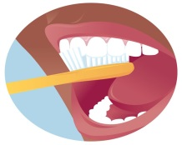 | 7:30-9:00am  Getting ready | Time to get up, washed, have breakfast and get dressed. Talk about the day ahead and ideas for activities, make and use a simple picture timetable, Use communication as appropriate to the abilities of your child- signalong, pictures, facial expressions and gestures
 | 9:00am  ‘morning group’, box clever language play and physical activity | In Simmonds class we start with morning activities.  SEE RESOURCE SHEETS FOR THIS ACTIVITY. Listen to the good morning song on youtube. With pictures-.-hello song, how are you today song, days of the week song, whats the weather, who’se in the mirror, can you find your name.  After this, do box clever activity- choose some small toys linked to a theme or place eg toy animals, shopping, the park, cars etc and play a role play game using language linked to the objects. SEE THE RESOURCE SHEET FOR THIS ACTIVITY  Next, do some physical activity linked to your childs motor skill targets eg walking, stretching, standing frame, floor activities etc.  FOLLOW YOUR CHILD’S PHYSIOTHERAPY PROGRAMME
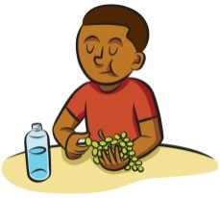 | 10:30am  Snack time, free outside play time | Snack time- offer your child a choice of a healthy snack. FOLLOW YOUR CHILD’S SELF HELP TARGET when snacking eg independently finger feed themselves. Is there an opportunity for your child to get active? Is there a possibility to get outside and explore an outside area ?
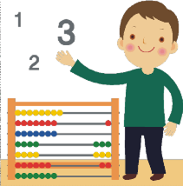 | 11:00am  Cognition-maths/language | Listen to and join in with some favourite counting/ letter sound songs on youtube. Eg 5 little monkeys, 5 men in a flying saucer/ 5 little ducks etc. language songs- abc song, songs which get the hands ready for writing eg tommy thumb, wind the bobbin up, open and shut them, heads shoulders knees and toes.  Now do some mark making using appropriately sized pens or pencils, practicing circles , zig zags, side to side, up and down, and tracing letters and shapes.  Now some children can now explore simple words eg I, like, mum, dad, and , cut these out and make simple sentences with them. use pictures from a catalogue to make sentences eg I, like, the, then a picture ( make 3 sentences like this), or picture and picture (make 3 sentences like this) then ‘read’ the sentences eg i…like… the….car; i.. like… the… doll etc ; or mum… and … dad or for a challenge , eg I.. like… the.. car and ..the .. doll. (words shown in italics should be pictures)  SEE RESOURCE SHEETS FOR EXAMPLES, WORDS AND PICTURES  Now some children can explore letter sounds eg s,a,t,p,I, show them some pictures of things that begin with these letters. Can they find a letter from a choice of 2 or 3? Can they match letters?  Now explore a favourite story book, talking about the pictures and what is happening in the story. Then let your child explore a variety of books for themselves.  Now Take a physical break  Now look at some numbers, colours and shapes—fun activities with construction toys eg large lego. Build a tower and count the bricks. Match the bricks to numbers eg put 2 bricks with number 2; put numbers in order up to 5 or 10, put all the red ones together etc. Could you do some ‘real life’ maths together such as weighing ingredients for lunch or counting coins out and playing shops?  SEE RESOURCE SHEETS FOR MATHS ACTIVITIES
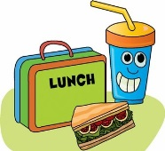 | 12:00  Lunch and playtime | Could your child help to prepare the lunch, clear up and wash up?  For playtime, is there a chance to get active again? Or could your child choose an activity they enjoy such as drawing / colouring…
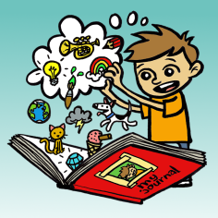 | Afternoon | In Simmonds class, we tend to do more of the creative subjects in the afternoon.  -Painting using large paintbrushes or hands/finger prints  SEE ART RESOURCE SHEET FOR ART ACTIVITY  SEE RESOURCE SHEET FORM PLOAYDOUGH RECIPE  -junk modelling something out of old boxes/containers  -Cutting and sticking shapes  -Water play eg washing a doll or plastic toys  -sand play eg dinosaurs in the sand  -going on a hunt together for natural items outside and using to create some art work or just explore them with your hands  Exploring light toys and torches  Using musical instruments to play along with favourite toys  -Messy food activities eg exploring pasta in a bowl mixed up with other ingredients- whatever you think your child will tolerate  SEE RESOURCE SHEET FOR ACTIVITIES
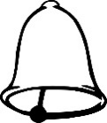 | End of the day | Sing a goodbye song  AFTERNOON EXPLORING SHEET FOR GOODBYE/HOME TIME SONGS  It is important to think about when to end the day and separate home time.
This may help you – or you may choose to set your own timetable! There is lots of advice and suggestions online if this doesn’t really suit you. Timings will also vary depending on needs and attention span of your child -children in Simmonds class have a much shorter attention span and will need shorter times spent on each activity.

