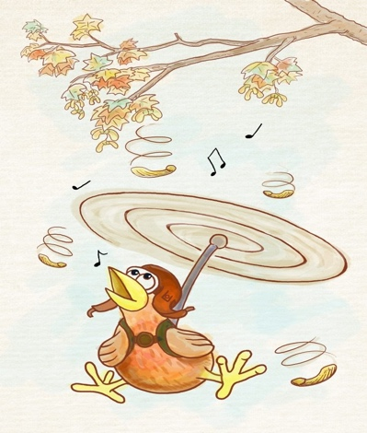
Pilot Pigeon
By Logan Norman (6K)

A normal day, a normal life but a spy called Walter , his life is added with a little spice. Some of the missions he had succeeded, are dangerous and life threatening. He needs to crack secret codes and quizzes that are mind boggling.

Today seemed like any ordinary day. Walter was flicking through the newspaper while drinking his coffee. Suddenly, he spotted something out of the corner of his eye. A pigeon with a half eaten rotten donut hanging from his beak. He recognised the pigeon and jumped from his armchair, throwing the sheets of newspaper across the room. He remembered the last scenario he was in with this crazy pigeon and the chaos it caused with the rocket. Walter hoped that his cover hadn’t been blown and he could continue his mission.

Walter began to panic and ran to his cellar , deep underground (under his house). He quickly typed the combination code in and waited for the lock to click. He pushed the door so hard that he tumbled down the stairs , but as he tumbled down his shoe got caught in between the door to the cellar. Walter was feeling lightheaded as he tried to get up from his fall. What he did not know was the pigeon had sneaked into the secret cellar without him knowing.

Suddenly Walter could hear the loud buzzing of the alarm and ran as fast a cheater. He could see the pigeon sat on his giant red button. He commanded the pigeon to stop but it was too late! In the blink of an eye, the pigeon was attached to a flying drone whizzing around.
The flying drone crashed through the air vent and out through the chimney. Walter was filled with adrenaline and ran up the stairs to try and stop the pigeon and flying drone. Walter grabbed his briefcase and looked at the coordinates to track the drone. He jumped in his car, he had to stop this pigeon before it caused any more devastation. He drove frantically through the rush hour traffic zig zagging in and out of the cars . All of sudden …. BOOM!!!!! One of the planes that were hunting down the drone along with the pigeon crashed straight down into the highway. The flames were red and the smoke was black. Cars began crashing and people started panicking. Walter had lost track of the destructive drone and there was no way through the thick smoke.

Walter had an idea , he remembered his sandwiches in his briefcase . He grabbed them and stepped out of the vehicle and waved a piece of the snack in the air . Walter knew the pigeon couldn’t resist food, the ham sandwich looked too good to resist. The pigeon dived out of the machine and swopped towards the food. The pigeon grabbed it out of Walters hand and sat happily eating the sandwich as if nothing had happened.

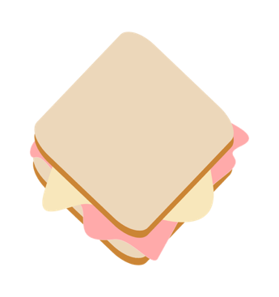

The End

