LEARNING FROM HOME
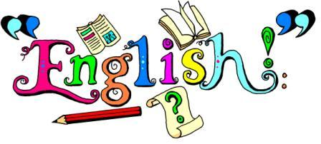
YEAR 4 – Week Beginning 01.06.20
- This term, we will practise publishing skills in Computing. Therefore, it would be beneficial to do English writing task using Purple Mash-Tools- 2Publish Plus, which has a selection of blank writing templates. The Book Review template includes steps & tips too. The typed work will need to be saved on your device and uploaded to Google Classroom for us to read How to use the 2 Publish Plus tool, please read the Computing pdf in our Google classroom ( Step by step guide with pictures). The main activity in English & Computing will be to write a book review, as we just finished reading ’Oliver Twist’ by Charles Dickens. If you prefer to use paper and pen, please do so! (You will be able to type the review during computing task practise)
- Please complete the Reading comprehension activity. Finished? Complete the challenge too
- Our grammar focus this week is Prefixes and suffixes. Go through the PowerPoint to recap them and complete the grammar activity. Look at the challenge on the PowerPoint too!
- Are you ready for the Spelling and Handwriting Challenge?

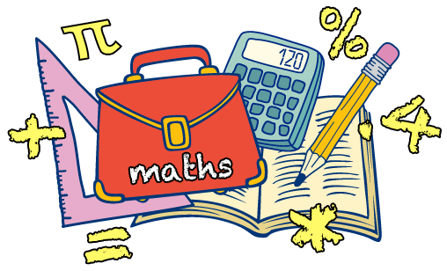
- Maths focus is revisiting Decimal addition and subtraction. Please read the PowerPoint and complete the tasks from the slides in your book. Can you complete the Challenge too? Remember to practise your Times Tables daily!

Electricity
- This term we will learn about electricity, starting from the basics: what is an appliance, what is mains electricity, other sources of electricity and much more!
- Main Activity on the slides: What does electricity make the following appliances do?
In your book draw some common household appliances, explain their use, possible dangers and
label the materials.

Topic: This week we will identify and explain some of the different ways people use the River Thames today. Before we begin, it is important to understand how rivers form, know the key vocabulary we use to describe rivers, and finally, how The River Thames use differ from the Victorian era.
RE: This week we are going to look at how we are influenced by other people. Draw yourself and write all the things that influence you around. Extension and challenges are on the slides too!
Computing: Purple Mash 2 Publish Plus: Use your login to write Charles Dickens ‘Oliver Twist’ book review. Look through the Computing PowerPoint to guide you.
ART: This week you will research famous artist Piet Mondrian - please write facts about this artist and draw/paint in his style. Remember to upload your masterpieces!

PE: Ready to exercise and have fun? Have a look at our weekly Fitter Future suggested activities and time table in order to choose what you would like to try. Remember it is always worth to try new things and learn new skills Fancy to stick with the previous workouts? Visit: https://www.youtube.com/watch?v=T8jI4RnHHf0
Music: Watch the BBC video on pulse and rhythm.
https://www.bbc.co.uk/bitesize/topics/zcbkcj6/articles/z2mqw6f
Pick your favourite song and try to clap the pulse. Choose some interesting rhythms from the song and clap those too. You don’t need to upload anything for this task.

Home Learning in Year 4
Working with your child at home may seem a bit daunting in terms of keeping them occupied and
balancing time out. At school, we find keeping to routines a very helpful way of keeping children
focused and balancing out formal learning time with relaxation. This also applies to keeping fairly
regular bedtimes and getting up times to keep things as ‘normal’ as possible.

This may help you – or you may choose to set your own timetable! There is lots of advice and
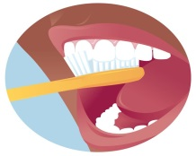 | 7:30-9:00am  Getting ready | Time to get up, washed, have breakfast and get dressed. Talk about the day ahead and ideas for activities.
 | 9:00am  Reading and Writing | At school, we start the day with some reading activities. This could be reading a book / newspaper / magazine / using online resources such as online news.  After this, perhaps you could think about some writing. Could your children write or draw something about the book they read? Could they choose a writing activity in their home learning book from school?
 | 10:30am | Time for a break and perhaps a snack. Is there an opportunity for your child to get active? Could they do some jogging / dancing if you are in the house? Is there a possibility to get outside for skipping / jumping / running?
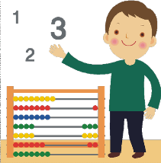 | 11:00am  Maths | There are lots of resources that can be accessed online to help your children get quicker at number facts, and the school will have sent some activities home. Try the BBC website and Times Table Rockstars among others.  Could you do some ‘real life’ maths together such as weighing ingredients for lunch or counting coins out and playing shops?
 | 12:00  Lunch and playtime | Could your child help to prepare the lunch, clear up and wash up?  For playtime, is there a chance to get active again? Or could your child chose an activity they enjoy such as drawing / colouring…
 | Afternoon | At school, we tend to do more of the creative subjects in the afternoon. As well as project ideas we have sent home, some other suggestions for ideas at home could be:  -junk modelling something out of old boxes/containers  -researching a famous person and presenting the information they found  -going on a hunt for natural items outside and using to create some art work  -arts and crafts – drawing/colouring/painting/creating  -Science such as freezing / melting, looking at plants and animals in or out of the house
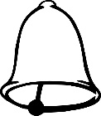 | End of the day | It is important to think about when to end the day and separate home time.
suggestions online if this doesn’t really suit you.

