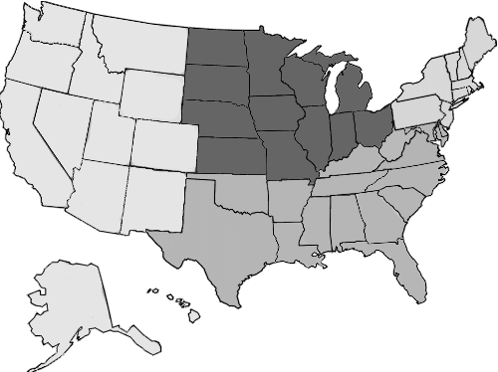

**The Midwest**

North Dakota, South Dakota, Minnesota, Wisconsin, Michigan, Ohio, Indiana, Illinois, Missouri, Iowa, Kansas and Nebraska.



**The North-East**

Pennsylvania, New York, Vermont, New Hampshire, Maine, Massachusetts, Connecticut, Rhode Island and New Jersey.



**The South**

Delaware, Maryland, West Virginia, Virginia, Kentucky, North Carolina, South Carolina, Georgia, Florida, Alabama, Mississippi, Louisiana, Texas, Oklahoma, Arkansas and Tennessee.



**The West**

New Mexico, Arizona, California, Nevada, Oregon, Washington, Montana, Wyoming, Idaho, Utah, Colorado.