Date: _________________________________
L.O. To recognise adverbs and use them in full sentences.
Spot the adverbs in the word search, then choose your 8 favourites and put them in interesting sentences with connectives and new punctuation.
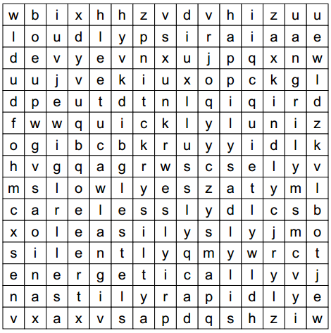

quickly, slowly, quietly,
loudly, happily, sadly,
silently, easily, angrily,
energetically, rapidly, kindly,
nastily, carelessly
Date: _________________________________
L.O. To recognise adverbs and use them in full sentences.
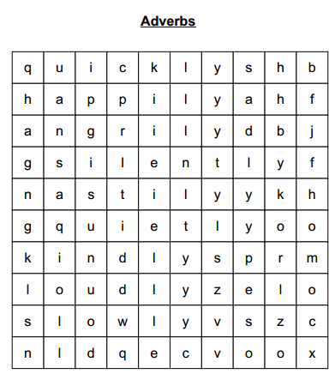
Spot the adverbs in the word search, then choose your 6 favourites and put them in interesting sentences with adjectives.

quickly, slowly, loudly,
quietly, kindly, nastily,
silently, angrily, happily, sadly

Date: _________________________________
L.O. To recognise adverbs and use them in full sentences.
Spot the adverbs in the word search, then choose your 4 favourites and put them in interesting sentences with adjectives.
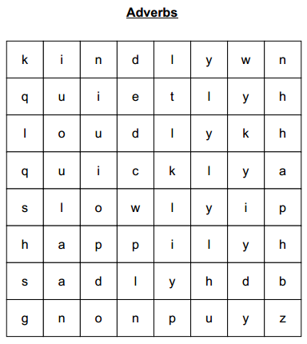

quickly, slowly, loudly,
quietly, kindly, happily, sadly

