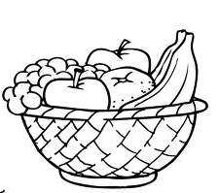
Favourite Fruit

Shoppers in the supermarket were asked in a survey which was their favourite fruit. Here is a list of their responses.

Banana Apple Banana Banana Grape Orange
Apple Apple Strawberry Orange Apple Banana
Orange Orange Strawberry Banana Grape Apple
Apple Apple Orange Strawberry Strawberry Apple

Copy this Tally Chart into your jotter and use the list above to complete it.

FRUIT | TALLY | TOTAL
Apple
Banana
Grape
Orange
Strawberry

Then use the information in the tally chart to answer the questions below in your jotters.

- Which fruit was the most popular?

- Which fruit was the least popular?

- Which two fruits were preferred by the same number of people?

- How many more people preferred Apples to Grapes?

- How many fewer people preferred Strawberries to Bananas?

- How many people were surveyed all together?

- Order the fruits from most popular to least popular?

