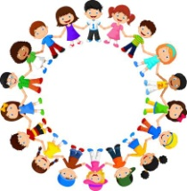

EYFS
Philosophy for Children

This week, I am going to share a image for you to look at with your child and you could do some more P4C as a family at home. Here are some questions you could ask them:
- What does the picture make you think about? Any first thoughts/ideas/themes (You could share what it made you think about too!) E.g. animals, real or not real, friendship
- Could you think of a question about one of the ideas/themes that the book made you think about? E.g. Can cats and mice ever be friends?
Then you could have a chat about the question you chose together, the one you think you will have lots to talk about together.

Here is your image
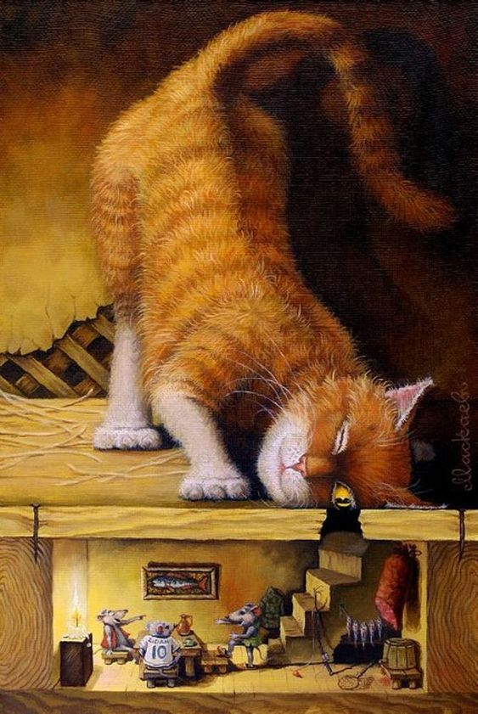
Some big ideas the children may think of (although they may think of lots more): Friendship, fear, real or not real, happiness
Questions you may want to discuss: Can cats and mice ever be friends? Do mice really have little houses under the floor boards? Who is happier the cat or the mice?

