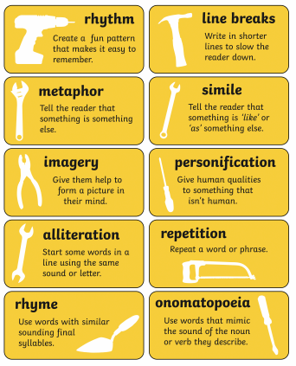

Great poems are often based on something that is personal to the author. It might express something they have or currently do see, feel or think about. Poetry can be a way of practising mindfulness; by writing down how you feel, you can turn negative emotions into positive ones.

There are several videos on the link below that you can use as inspiration. You can also use some of the videos from last week’s learning if you would prefer. Or, like previously mentioned, you can choose what to write about.

[www.literacyshed.com/the-poetry-shed.html](http://www.literacyshed.com/the-poetry-shed.html)

This week would you like to write your own poem.

You can use the Literacy Shed links below as inspiration, or you can make up a poem about a topic of your choosing (Spring, being in isolation etc.)

Some examples of famous poems can be found in the folder. Read these examples and think about the following questions.

* What do you notice about these poems?
* Can you spot the features of poetry in them?
* Which ones is your favourite and why?
* Are you able to use these as inspiration for your own writing?

You can see that we get lots of different types of poems – you can write whatever type of poem you like.

Remember, poems don’t have to rhyme and they don’t have to have proper punctuation!

Success Criteria:

* Figurative language (metaphors, alliteration, personification, similes, onomatopoeia)
* Expanded noun phrases
* Adjectives, verbs and adverbs
* High level vocabulary – use a thesaurus
* Playful punctuation
* **CHALLENGE (Mr Rowell, Miss Wilcox and Mrs Maule’s groups): NO RHYMING COUPLETS (we don’t want the end of each line to rhyme).**