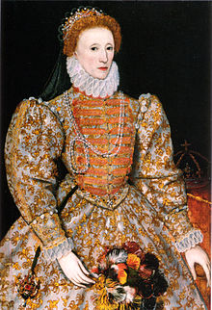 | 
              

