What is a coordinating conjunction?
A conjunction is a type of connective ('connective' is an umbrella term for any word that connects bits of text together). A conjunction connects two clauses, phrases or words in a sentence.
We use co-ordinating conjunctions to join two parts of a sentence that are of equal weight or importance. Use a coordinating conjunction when you want to give equal emphasis to two main clauses.
And, but, for, nor, or, so, and yet—these are the seven coordinating conjunctions. To remember all seven, you might want to learn this acronym: FANBOYS

F = for
A = and
N = nor
B = but
O = or
Y = yet
S = so

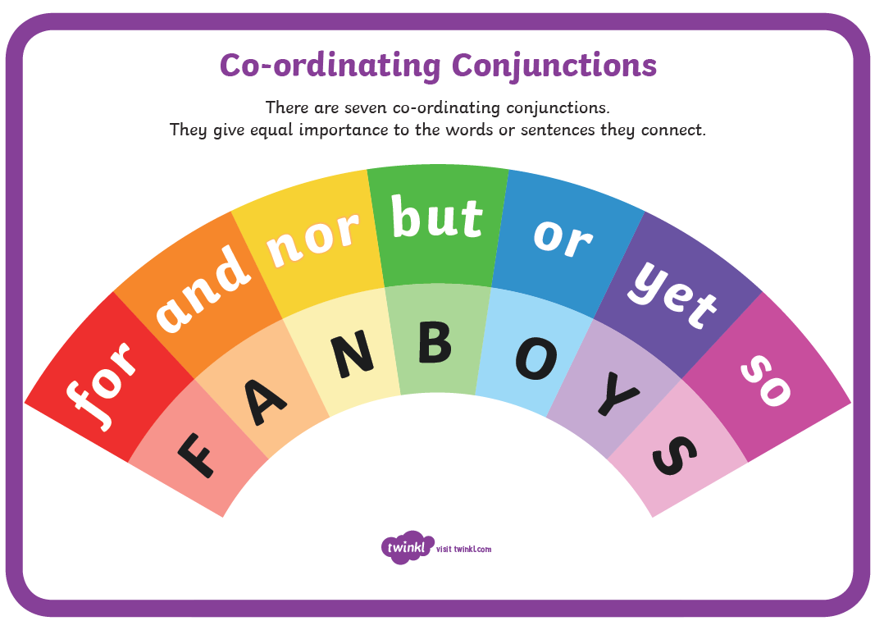
Look at the examples that follow:
The bowl of squid eyeball stew is hot and delicious.
The squid eyeball stew is so thick that you can eat it with a fork or spoon.
Rocky, my orange tomcat loves having his head scratched but hates getting his claws trimmed.
Rocky terrorizes the poodles next door yet adores the German shepherd across the street.
Rocky refuses to eat dry cat food, nor will he touch a saucer of squid eyeball stew.
I hate to waste a single drop of squid eyeball stew, for it is expensive and time-consuming to make.
Even though I added cream to the squid eyeball stew, Rocky ignored his serving, so I got a spoon and ate it myself.

