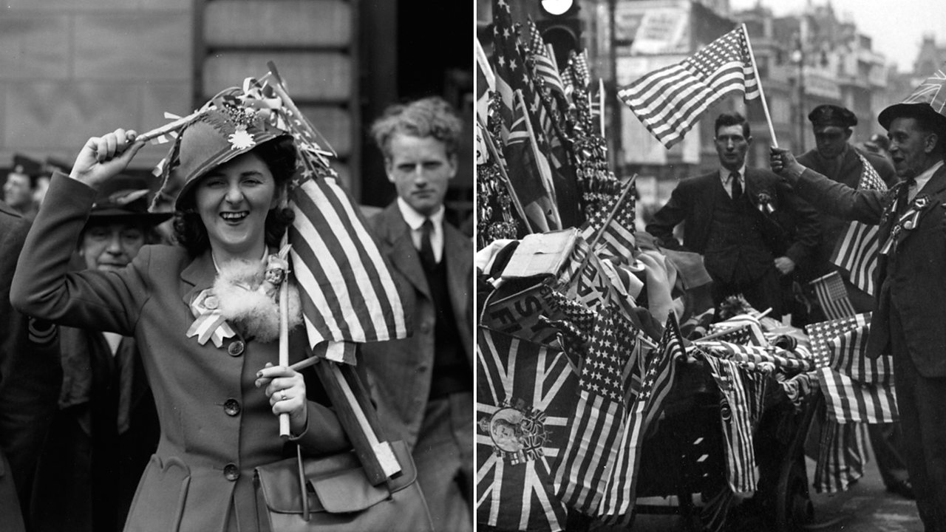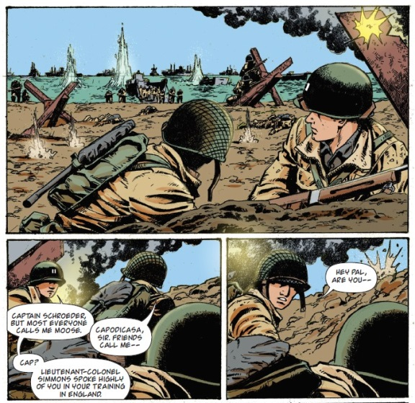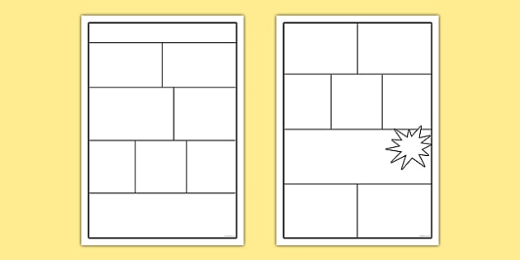

**VE Day Activity**

**VE Day**

Victory in Europe Day, generally shortened to VE Day or V-E Day, celebrates the formal acceptance by the Allies of World War II of Nazi Germany's unconditional surrender of armed forces on **8 May 1945.**

Step 1

<https://www.iwm.org.uk/history/what-you-need-to-know-about-ve-day>

<https://www.bbc.co.uk/teach/ve-day-How-did-the-british-plan-to-celebrate/zndn7nb>

Using the links above, internet search engines or any reference books you might have, find as much secondary evidence as you can about VE Day.

Do you have anyone in your family that remembers it – perhaps as a young child? If so, could you get them to tell you about it as a source of Primary evidence?

Step 2

Use your research to create a graphic novel or poster about VE-Day. Find ways to include the facts you have learnt from your research. The best ones will earn you Dojo Points and we will find a way of putting them in the photo gallery of the school web site.