Rhyming Words
Here is a poem about spring. Can you underline the rhyming words?
Remember rhyming words end in the same sound. If you aren’t sure have a look on BBC Bite size to remind you.
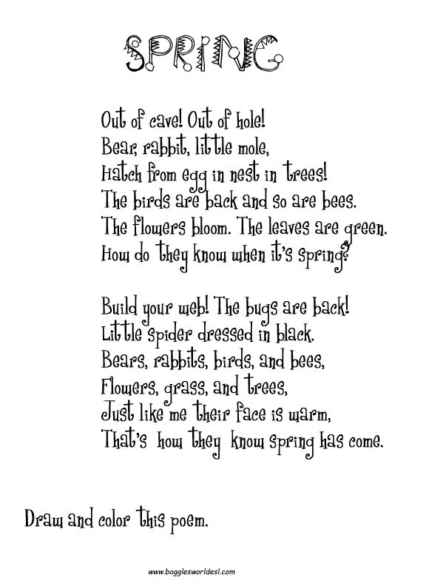

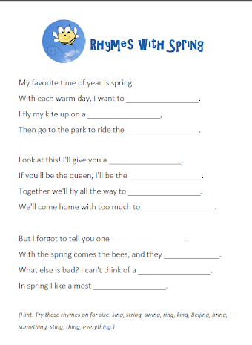
Have a go at making your own spring rhyming poem. If you are struggling use the template to help you.

