LEARNING FROM HOME – Nursery Additional activities
Week beginning 8.6.20
- Recap your (set 1 speed sounds).
Use https://www.youtube.com/watch?v=h8m6YFr0gig
or https://www.youtube.com/watch?v=qB6SvZscxgg
If you are unsure how to pronounce the sounds.

- Complete letter formation worksheet provided or practise using pencil and paper https://www.youtube.com/watch?v=vsue4unC7YQ&t=1154s

Phonics games:
https://www.starfall.com/h/abcs/
https://www.oxfordowl.co.uk/api/interactives/24467.html

- Sensory/numeracy:
Can you use homemade playdoh and make different transport? (Use the transport word mat provided for images and ideas and playdoh recipe sheet)
Can you count how many you have made?
What colours do you know? Can you colour the transport pictures (worksheet provided) and name the colours you have used?
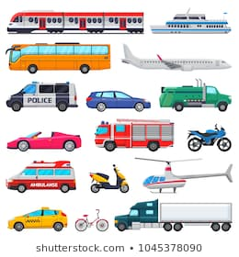
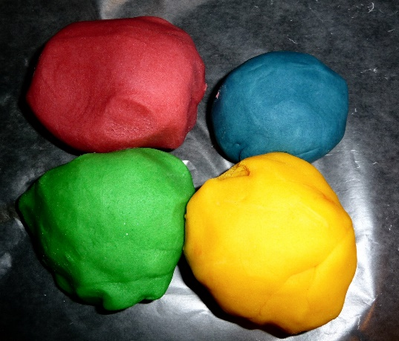
This Photo by Unknown Author is licensed under CC BY-NC-ND

