Science
Summer 1 Week 3
Objective:
- To observe, research and record features of a range of leaves found in their local environment.

You are going to explore your gardens and your local area to find a range of different leaves from trees and plants. Using the leaves that you find, you will classify the trees or plants and identify their species. You will then be able to sketch the leaves and label them with what tree/plant they are from. You can then describe the features of the different leaves that you find.

Example:

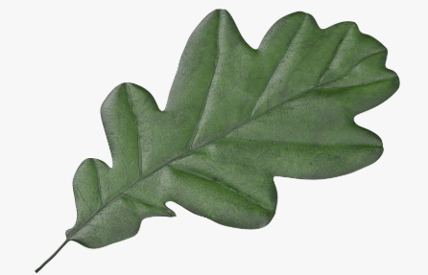
Oak leaf from an oak tree
Feature:
-rounded parts
-middle vein
-short stalk
-slightly shiny top

Next, you will be able to carry out some botanical drawings of the trees. You will be able to sketch part of the tree/plant, leaves and the seed from which it grows.

Example:

