Home Learning in Year 2

Working with your child at home may seem a bit daunting in terms of keeping them occupied and balancing time out.

At school, we find keeping to routines a very helpful way of keeping children focused and balancing out formal learning time with relaxation. This also applies to keeping fairly regular bedtimes and getting up times to keep things are ‘normal’ as possible.
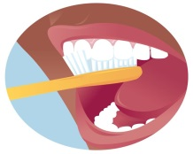 | 7:30-9:00am  Getting ready | Time to get up, washed, have breakfast and get dressed. Talk about the day ahead and ideas for activities.
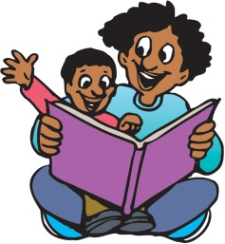 | 9:00am  Reading and Writing | At school we start the day with some reading activities. This could be reading a book / newspaper / magazine / using online resources such as online news.  After this, perhaps you could think about some writing. Could your children write or draw something about the book they read? Could they choose a writing activity in their home learning from school?
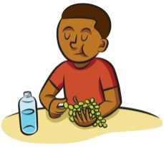 | 10:30am | Time for a break and perhaps a snack. Is there an opportunity for your child to get active? Could they do some jogging / dancing if you are in the house? Is there a possibility to get outside for skipping / jumping / running?
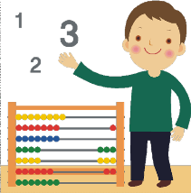 | 11:00am  Maths | There are lots of resources that can be accessed online to help your children get quicker at number facts, and the school will have sent some activities home. Try the BBC website and Times Table Rockstars among others.  Could you do some ‘real life’ maths together such as weighing ingredients for lunch or counting coins out and playing shops?
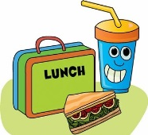 | 12:00  Lunch and playtime | Could your child help to prepare the lunch, clear up and wash up?  For playtime, is there a chance to get active again? Or could your child chose an activity they enjoy such as drawing / colouring…
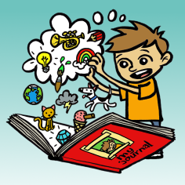 | Afternoon | At school, we tend to do more of the creative subjects in the afternoon. As well as project ideas we have sent home, some other suggestions for ideas at home could be:  - junk modelling something out of old boxes/containers  - researching a famous person and presenting the information they found  - going on a hunt for natural items outside and using to create some art work  - arts and crafts – drawing/colouring/painting/creating  - Science such as freezing / melting, looking at plants and animals in or out of the house
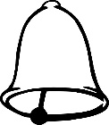 | End of the day | It is important to think about when to end the day and separate home time.

This may help you – or you may choose to set your own timetable! There is lots of advice and suggestions online if this doesn’t really suit you.

