The Visitor

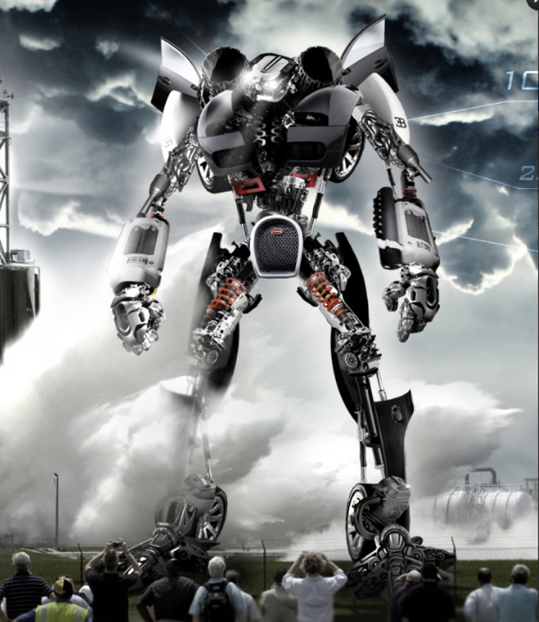

Task 1) Question time!
Who do you think is controlling the robot? Does it have a mind of its own?
………………………………………………………………………………………………….
Where has the robot come from?
…………………………………………………………………………………………............
Are the people in danger? How?
………………………………………………………………………………………………….
Can you think of a good name for the robot?
………………………………………………………………………………………………….
Is there a chance that robots will become part of our society in the future? How?
………………………………………………………………………………………………….

Task 2) Sentence challenge!
A preposition is a word that shows the relationship between one thing and another.
It may tell you where a thing is in relation to something else. E.g. The silver, shining giant stood on the car.
It may tell you when something is in relation to another event. E.g. The crowd watched until the giant departed.
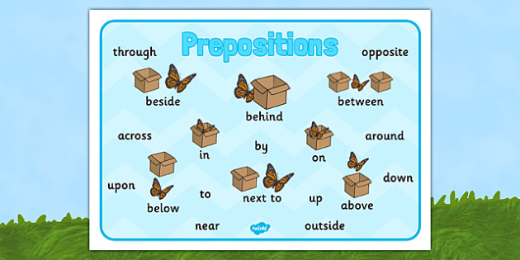
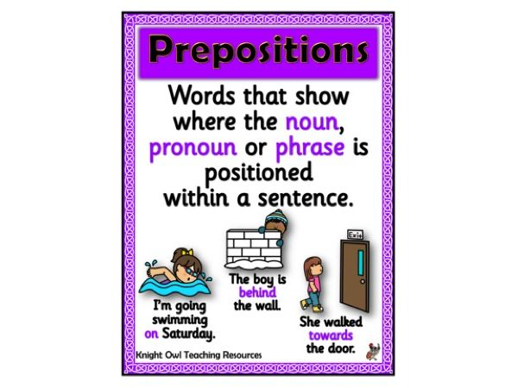

Looking at the picture of the robot, can you write 3 sentences that contain prepositions?
Is it possible to begin a sentence with a preposition? Can you end a sentence with a preposition? Now try to start and end a sentence with a preposition.

Task 3) Sick sentences!
These sentences are ‘sick’ and need help to get better. Can you help?

The robot stood in front of the people.

…………………………………………………………………………………………………

His hands and feet were big, and his body was really big.

………………………………………………………………………………………………….

Task 4) Perfect picture!
Imagine your job is to design a robot. Draw or describe what your robot would look like, and what it could do. This task will need completing in your home learning books. Alternatively, you can take a photo of your robot and send it to the following email address: UKS2@northbeckton.ttlt.academy

Task 5) Story starter!

See if you can complete the story. Don’t forget to add in prepositions.
Snap…Snap…Click…The sound of a hundred cameras filled the air.
Craning their necks to the skies to see the enormous specimen, the crowd all let out gasps and moans in unison as the figure took its first steps.
Standing over 50 metres tall, the metal beast cast a foreboding shadow over the gathering, transfixed spectators. No-one knew why it was here. No-one knew where it had come from. No-one knew whose side it was on. However, its intentions were about to be made clear………………………………………………………………….....
………………………………………………………………………………………………..
………………………………………………………………………………………………..
………………………………………………………………………………………………..
………………………………………………………………………………………………..
………………………………………………………………………………………………..
………………………………………………………………………………………………..
………………………………………………………………………………………………..
………………………………………………………………………………………………..
………………………………………………………………………………………………..
………………………………………………………………………………………………...
…………………………………………………………………………………………………
…………………………………………………………………………………………………
………………………………………………………………………………………………….
………………………………………………………………………………………………….
………………………………………………………………………………………………….
………………………………………………………………………………………………….
…………………………………………………………………………………………………

