Maths Monday- Introduction to measurement
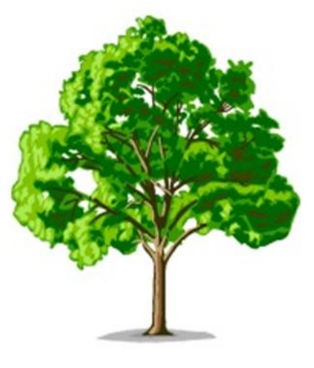

How would you work out how tall a large tree is?

…………………………………………………………………………………………………………………………………………………………………….

Which equipment would you use?
…………………………………………………………………………………………………………………………………………………………………….

Which unit of measurement would you use?

…………………………………………………………………………………………………………………………………………………………………….

Find something at home that is very large for e.g. a door, a cupboard, a wall etc. See if you can work out how tall it is. Give details on what approach you took to measure it.

…………………………………………………………………………………………………………………………………………………………………….
…………………………………………………………………………………………………………………………………………………………………….

