How water enters the leaf

The water needed for photosynthesis is absorbed through the roots and transported through tubes to the leaf.
The roots have a type of cell called a root hair cell. These project out from the root into the soil, and have a big surface area and thin walls. This lets water pass into them easily.
Note that root cells do not contain chloroplasts, as they are normally in the dark and cannot carry out photosynthesis.
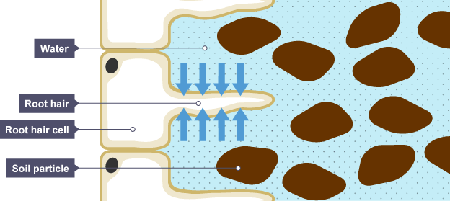
Xylem tissue delivers water from the roots to the leaf, and phloem tissue transports glucose away from the leaf.
