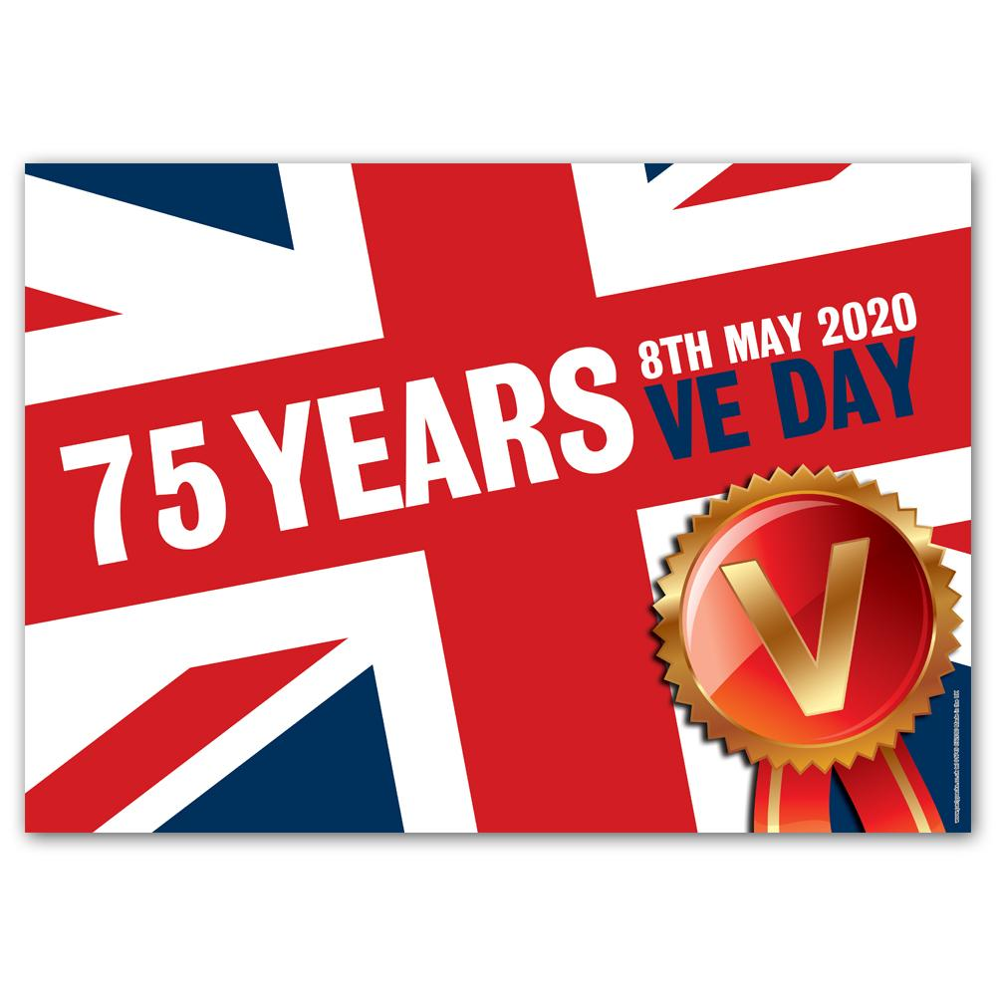

When is VE Day in 2020? Why do we celebrate it? And is it a Bank Holiday? As we look forward to two Bank Holidays in May 2020, one of them has been pushed back by four days for the whole of the UK to coincide with the 75th anniversary of VE Day. But what is VE Day and when is it celebrated? Here’s what you need to know.

When is VE Day 2020? While May Day is traditionally held on a Monday, it will be put back to Friday 8 May 2020. The May Day bank holiday has only been moved once before, when it was shifted from 1 May to 8 May in 1995 to mark the 50th anniversary of VE Day.

Why are we celebrating VE Day? VE Day stands for Victory in Europe Day, which took place on Tuesday, May 8 in 1945.It marked the end of World War II, and was the day on which allied forces announced the surrender of Germany in Europe. 75 years later, Business Secretary Greg Clark said it is important we continue to 'honour our heroes'.

He said: "It will ensure as many people as possible have the opportunity to remember and honour our heroes of the Second World War and reflect on the sacrifices of a generation."
How was VE Day celebrated in 1945? In 1945, 50,000 people packed into Piccadilly Circus waving flags and dancing and singing.
To find out more, watch the video on the website below:
https://www.bbc.co.uk/teach/class-clips-video/history-ks2-ve-day/z7xtmfr

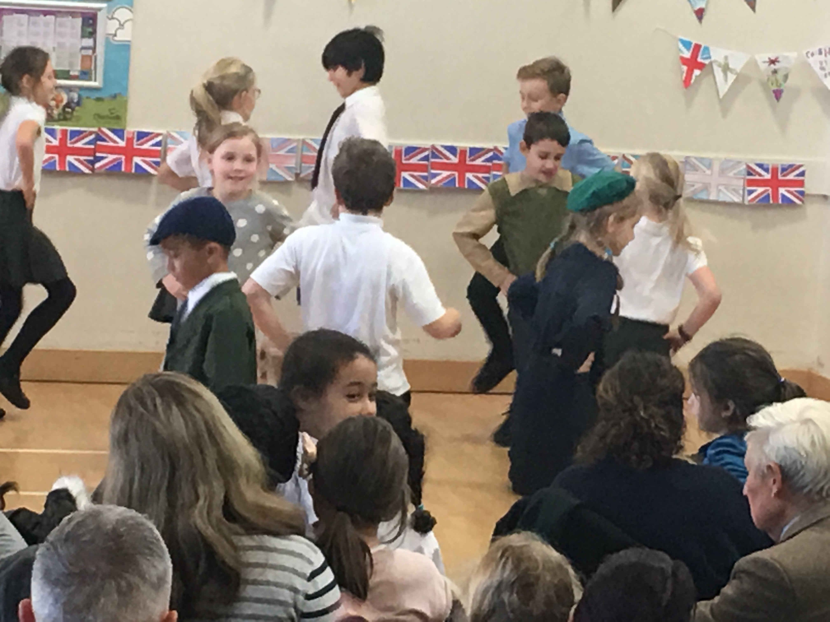
Do something to celebrate VE Day in your own homes and share this with us through the UKS2@northbeckton.ttlt.academy email account. These will be shared on our website.
Here are a few suggestions on what you can do but please be as creative as you like!
- Create decorations and decorate your living room.
- Have an afternoon tea party.
- Bake a VE day themed cake.
- Make your own flags.
- Come up with your own VE day dance/ song / poem / music piece (this can be recorded on video).
- Produce your own VE day art piece/ costume.
- Dress up!

