**SIGNS TO USE DURING MORNING GROUP**

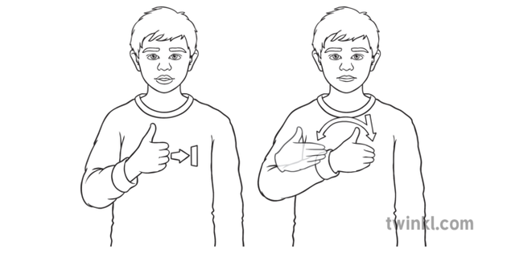

**GOOD MORNING**

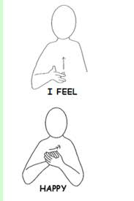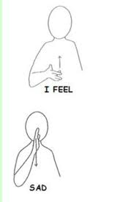

**FEELINGS SIGNS**

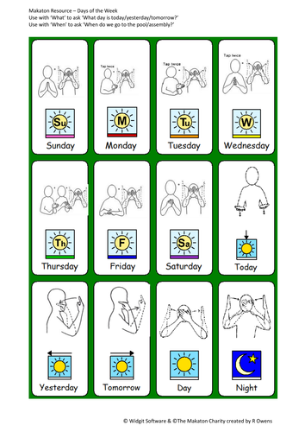

**DAYS OF THE WEEK SIGNS (PTO)**

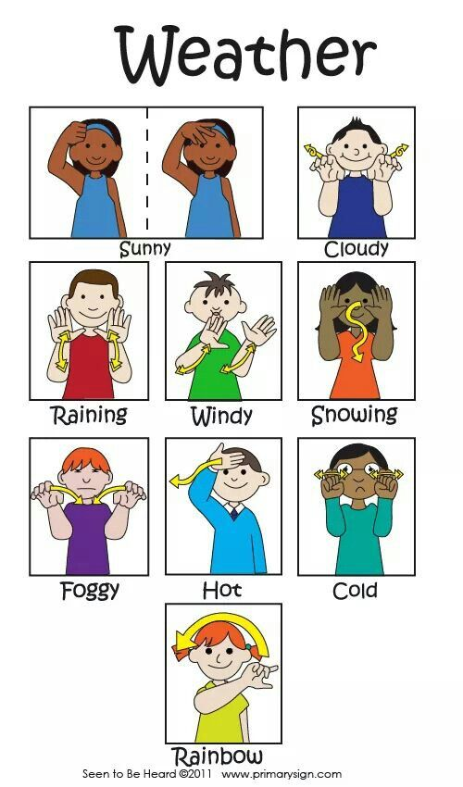

**WEATHER SIGNS**

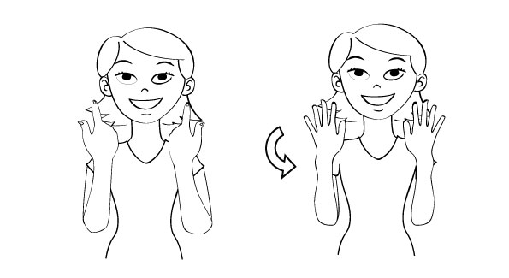

**ALL FINISHED**