Maths - 4.5.20
Measurement and ratio
Journaling - ratio
- Research a recipe – such as bread or a cake.
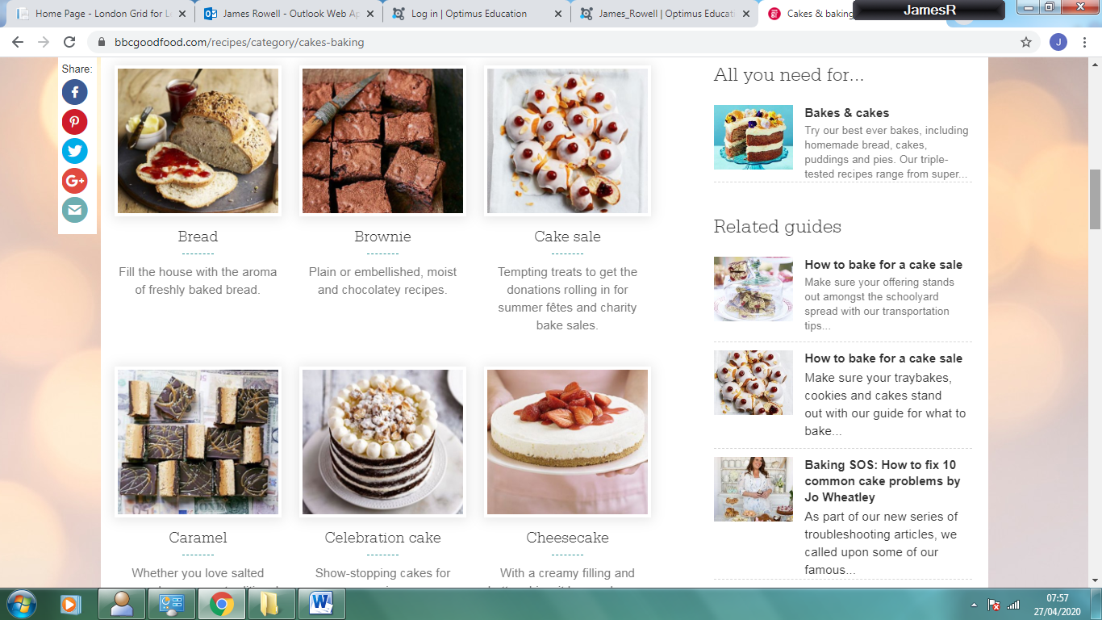
BBC foodfood.com is a good place to look online, or you might have some recipe books in your home.

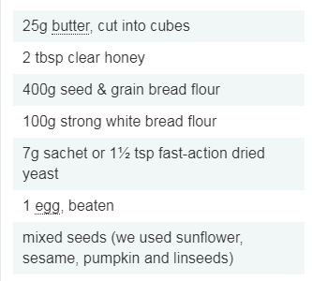
2. Make a presentation showing the quantities and how many it feeds.
Next, using your knowledge of ration, show the quantities needed for feeding different amounts of people. So, for example, if the recipe to the right fed 4 people, what quantities would you need to feed 8, 12 or 20 people? Display this information in your book and explain with diagrams how you arrived at your results.
Visit this BBC Bitesize page to remind yourself
what ratios are.
https://www.bbc.co.uk/bitesize/topics/zsq7hyc

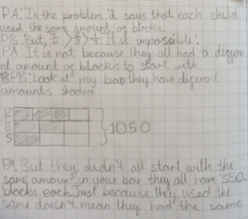
An example of Maths journaling using text and diagrams to remind you what to do.
If you would like to, bake or cook the recipe with an adult in your house as a fun activity to do together, don’t worry if you are unable to or don’t have the ingredients. Pictures or drawings of the prepared item would look good on your journaling page.

Part 2
Measurement challenge
Imagine that someone in Key Stage 1 is starting out reading scales.
Write a set of instructions with diagrams for measuring the different quantities used when baking. You will need to cover measuring the volume of liquids such as water or milk and weighing ingredients such as butter or flour.

The videos will help to remind you of the different steps needed.
https://www.youtube.com/watch?v=GFTlete-nMM
https://www.youtube.com/watch?v=bEEgQMskRBs
https://www.youtube.com/watch?v=cxK5Xd_NUok

Dojo Points to be awarded for good examples of work this week.

