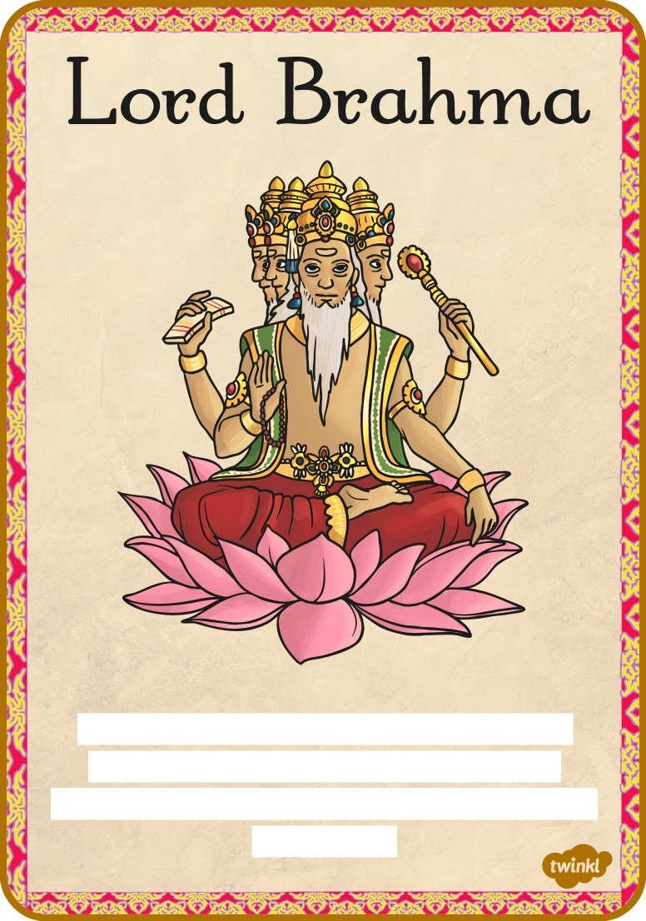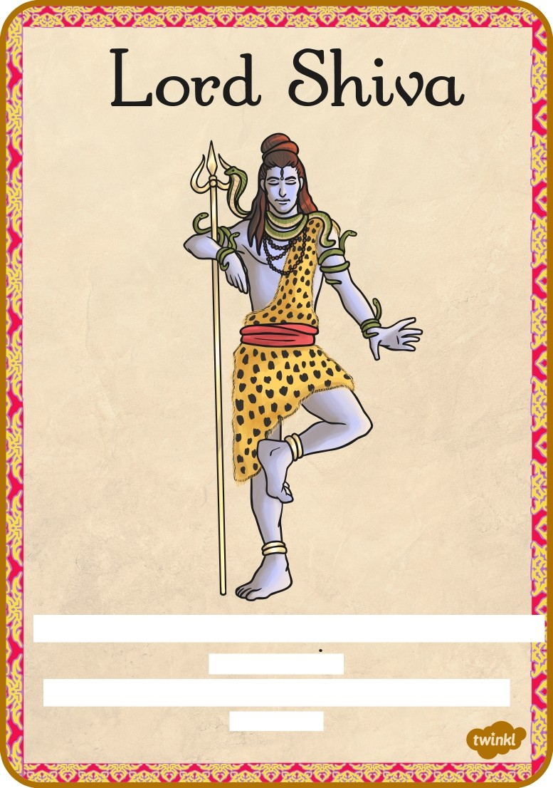

Brohmo is the creotor o/ the universe
ond oll knowledge. He hos 4 heods.
Vishnu ond Shivo ore the representotions
o/ Brohmo.

Shivo is the destroyer, so thot new li/e con )
come ogotn.
Shivo restores the bolonce between good ond evil.

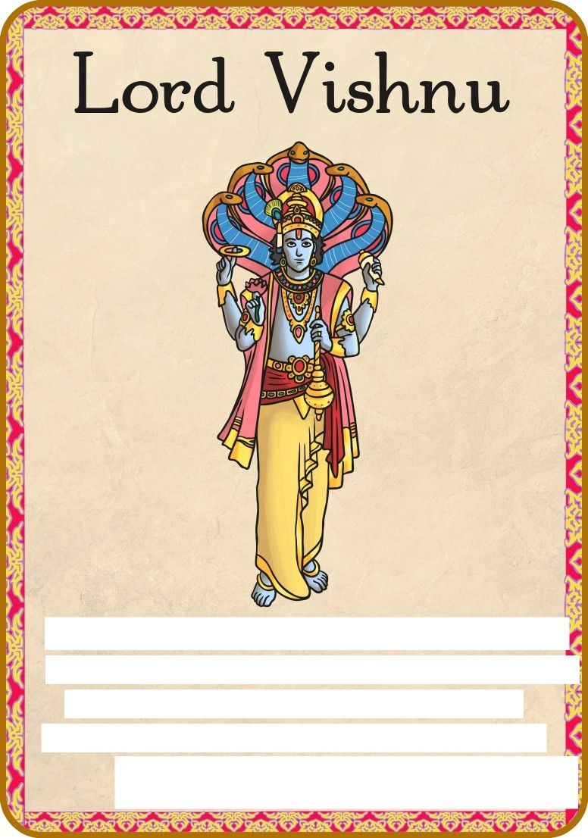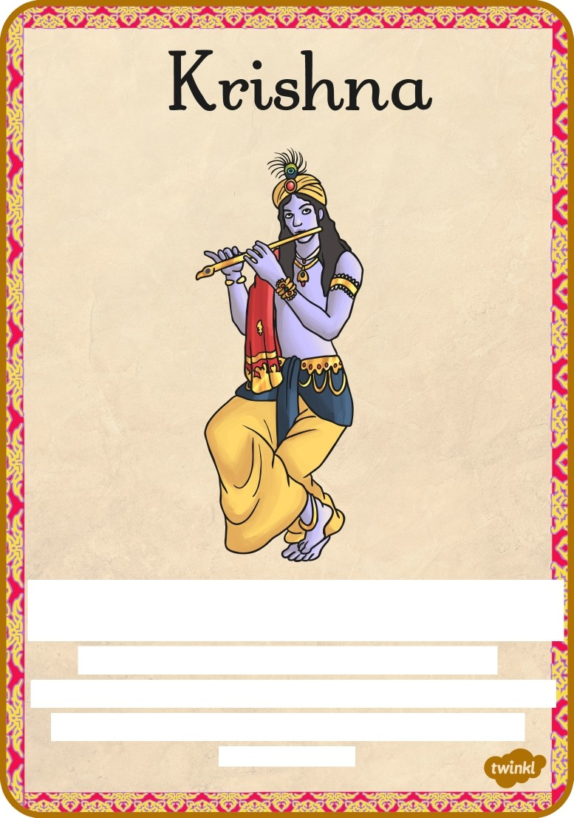

Vishnu helps preserve the people ond the universe. Hindus believe he hos oppeored 2
on Eorth in dijJerent Jorms to help his people. Vishnu hos Jour orms to represent
the Jour corners oJ the world. q

Krishno is o/ten seen with blue skin, ploping the (ute ond weoring peocock /eothers on j
his heod. He is the God o/ love ond devotion ond is the most worshipped o/ oll. '
Krishno is strong, poung, hondsome ond mischievous

Thank you for using www.freepdfconvert.com service!

Only two pages are converted. Please Sign Up to convert all pages. https://www.freepdfconvert.com/membership

