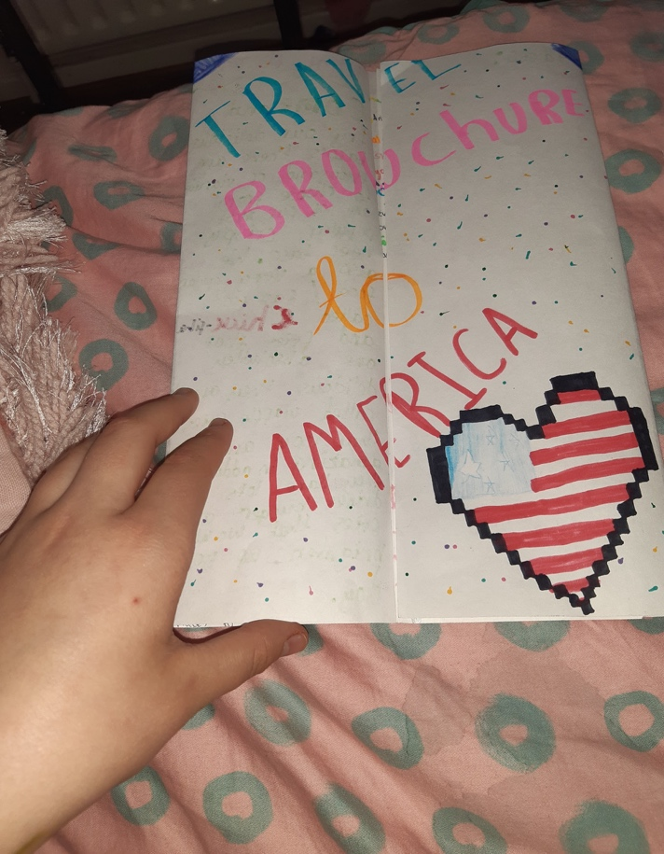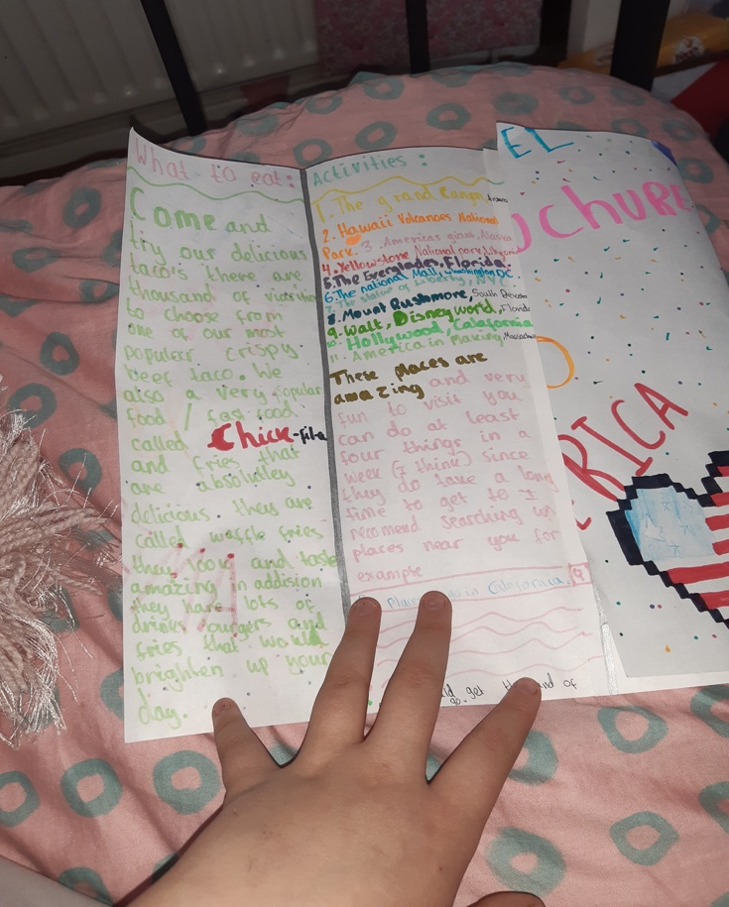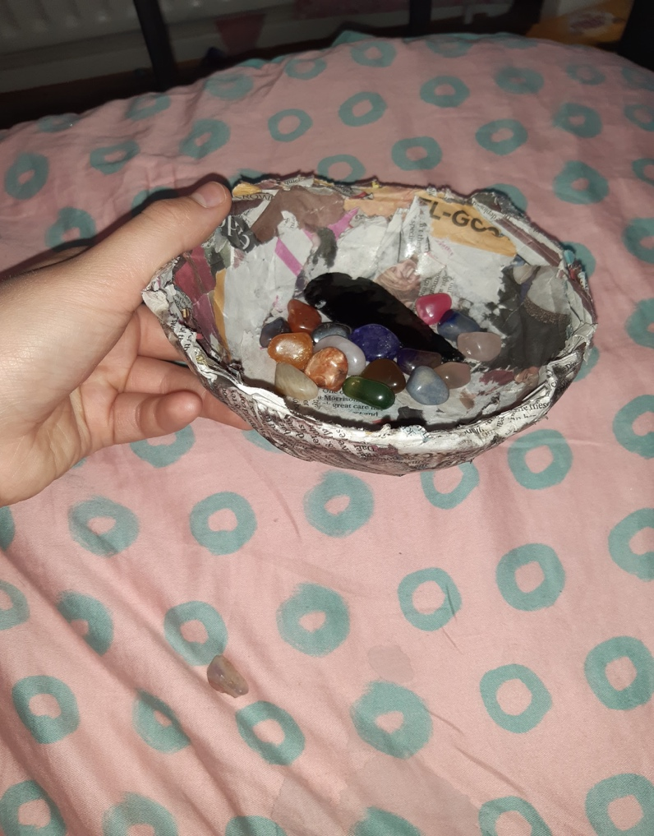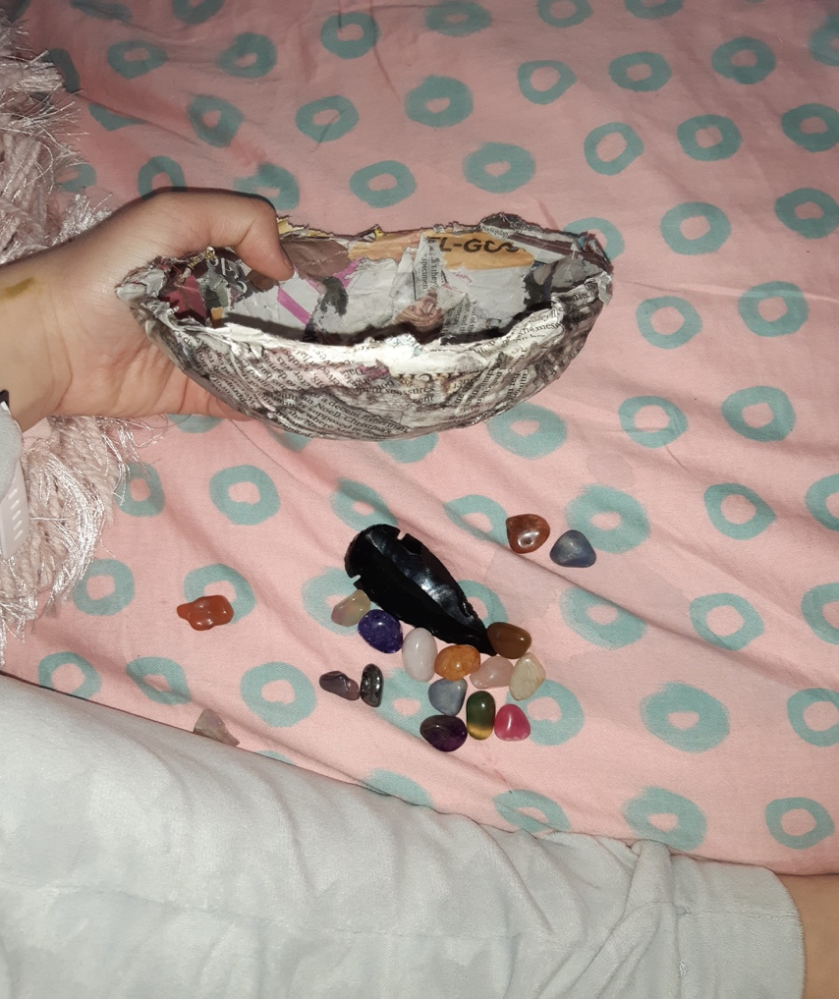

She has also made a bowl out of paper mache to keep some of her beautiful gem stones in!

Eva Kontenyten (6K) has researched about America and made a fantastic travel brochure as part of Year 6’s topic on North America.