Coloured playdough recipe

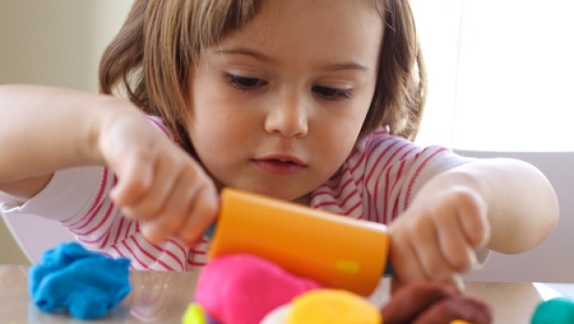
This super-easy playdough recipe is the perfect way to spend a rainy afternoon inside. It's quick enough to hold a young child's attention and you only need a few storecupboard ingredients. Little hands can play with the results straightaway, so there's immediate gratification for all involved!
Makes 1 coloured ball
Prep 10 minutes
You will need
- 8 tbsp plain flour
- 2 tbsp table salt
- 60ml warm water
- food colouring
- 1 tbsp vegetable oil
Method
1. Mix the flour and salt in a large bowl. In a separate bowl mix together the water, a few drops of food colouring and the oil.
2. Pour the coloured water into the flour mix and bring together with a spoon.
3. Dust a work surface with a little flour and turn out the dough. Knead together for a few minutes to form a smooth, pliable dough. If you want a more intense colour you can work in a few extra drops of food colouring.
4. Store in a plastic sandwich bag (squeeze out the air) in the fridge to keep it fresh.

