Mild- adding fractions with the same denominator

STS
First look at the numerators and add them together to find the new numerator
Remember the denominator always stays the same!
Simplify the fraction if you can!
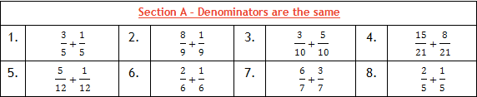
Spicy- Adding fractions with different denominators

STS
First look at the denominators
Then find lowest common multiple of each denominator
Multiple each fraction so they have the same denominator (the lowest common multiple)
Make sure you multiply the numerators too
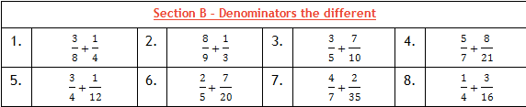
Finally, add the numerators but the denominator stays the same

HOT - Adding mixed numbers
STS
Multiply the whole number by the denominator
Add the numerator to this number
Put the new number over the original denominator
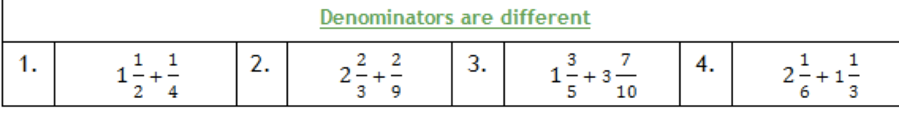
Use STS in spicy to add the new fractions together

Challenge! Word problems

