Name: _______________________ Date: _______________
Where is Pirate Pete?
Use the words at the bottom of the page to describe where Pirate Pete is standing.

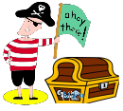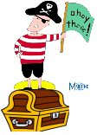
Pirate Pete is ________________ Pirate Pete is ________________
the treasure chest. the treasure chest.

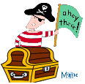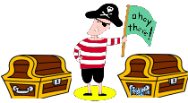
Pirate Pete is ________________ Pirate Pete is ________________
the treasure chest. the treasure chests.

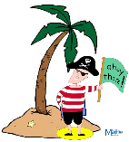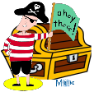
Pirate Pete is ________________ Pirate Pete is ________________
the palm tree. the treasure chest.
on top of
in between
under
next to
in front of
behind

