We put 6 frogs in the pot but 3 hopped out again. How many are there left in the pot? *A*



I had 8 wands but 4 got snapped. How many have I got now? *A*



I had 10 mice but 5 ran away. How many are left? *A*



I had 20 pots of potion but 10 got spilt. How many pots are left?

*A*



I had 35 broomsticks but 10 got snapped. How many are left? *A*

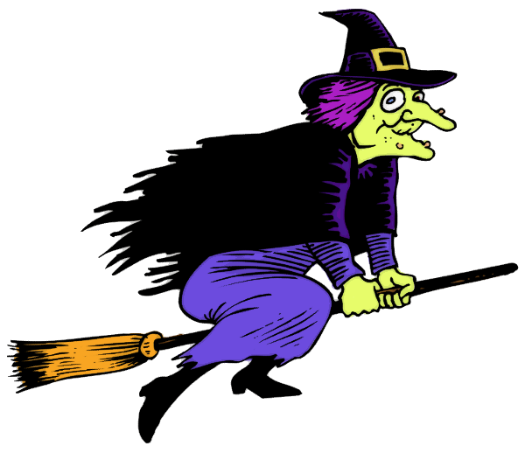

I had 50 black kittens but I sold 20. How many are left? *A*

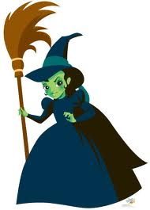

I put 10 slugs in my bowl for pudding but 6 escaped. How many are left? *A*

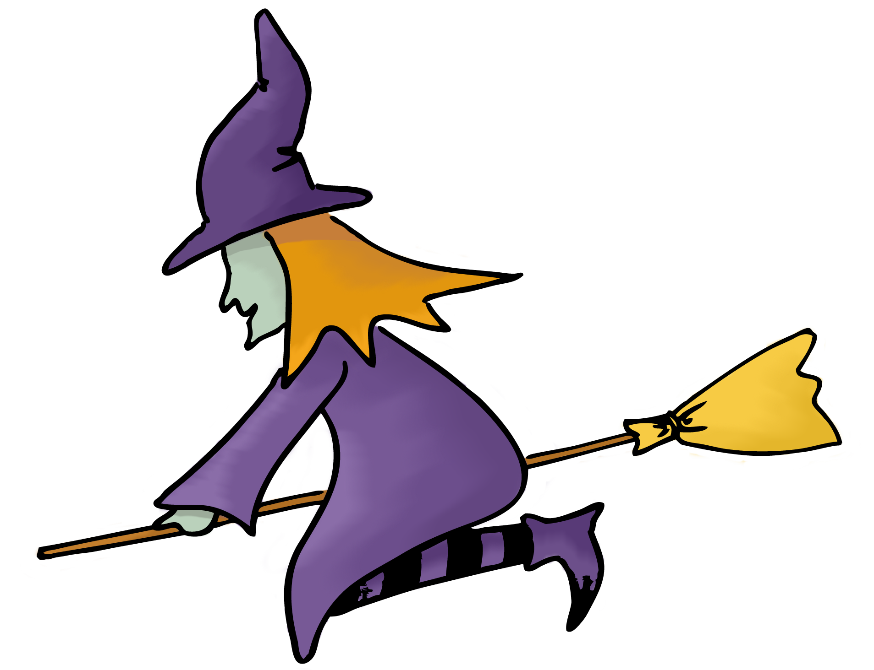

I planted 100 pumpkin seeds but the birds ate 50. How many seeds do I have left? *A*



We put 26 frogs in the pot but 8 hopped out again. How many are there left in the pot? *B*



I had 38 wands but 9 got snapped. How many have I got now? *B*



I had 20 mice but 5 ran away. How many are left? *B*



I had 24 pots of potion but 7 got spilt. How many pots are left?

*B*



I had 35 broomsticks but 9 got snapped. How many are left? *B*



I had 54 black kittens but I sold 8. How many are left? *B*



I put 20 slugs in my bowl for pudding but 6 escaped. How many are left? *B*



I planted 76 pumpkin seeds but the birds ate 8. How many seeds do I have left? *B*



We put 26 frogs in the pot but 13 hopped out again. How many are there left in the pot? *C*



I had 38 wands but 24 got snapped. How many have I got now? *C*



I had 18 mice but 9 ran away. How many are left? *C*



I had 67 pots of potion but 28 got spilt. How many pots are left?

*C*



I had 35 broomsticks but 17 got snapped. How many are left? *C*



I had 52 black kittens but I sold 11. How many are left? *C*



I put 93 slugs in my bowl for pudding but 12 escaped. How many are left? *C*



I planted 98 pumpkin seeds but the birds ate 89. How many seeds do I have left? *C*

