

***LEARNING FROM HOME***

***YEAR 1 – Week Beginning 01.06.20***

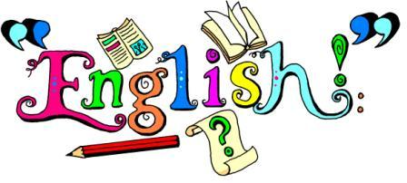

* Please download Studybugs if you haven’t already done so, so you can receive school updates and messages.
* **Phonics**- Try the I Spy and read activities in the phonics folder. Remember to use your steps for reading to help to read the words first.
* **Special Friends, Fred Talk, Say the word**.
* **English**- Choose 5 objects in your house. Who could they belong to? Create a character and write a story about them.
* **Grammar**- This week practise your handwriting and your spelling. You can find the words in the grammar folder.

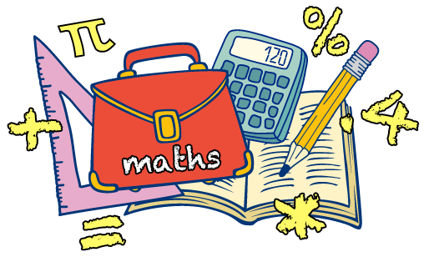

* We have learnt about the value of each digit in a number. We learnt about tens and ones in a number.
* <https://www.youtube.com/watch?v=1F3AycEDksY>
* <https://www.youtube.com/watch?v=T5Qf0qSSJFI> Watch these videos to help you complete the work.
* Complete the work in the maths folder.



Seasonal changes

* This week we are going to learn about Seasonal changes especially between Spring and Summer. Use the search engine ‘Kiddle’ to find out more about it.
* Draw the change from Spring to Summer. What are people wearing? What is the weather like? What do the plants look like? What animals can you see?
  + Watch the videos here to help you.

<https://www.youtube.com/watch?v=8ZjpI6fgYSY> https://youtu.be/eXFe4tUCd40



**History:** Our History topic is ‘Queen Elizabeth I and Queen Elizabeth II. This week create a timeline of Kings and Queens of England. Use the pictures in the folder to help you.

**RE:**This term we will be learning about ‘Hinduism’. This week explore different artefacts in hinduism. There are some activities and pictures in the RE folder. Watch these videos to learn more. <https://www.youtube.com/watch?v=jDc4CJscWws> <https://www.youtube.com/watch?v=o-s0mN5P8jo>

**Computing**: Purple Mash: Use your log-in to explore all the games available. Explore 2Paint.

**D&T:** We are learning about different fruit and vegetables. Watch these videos to help you complete with work in the D&T folder or draw a poster about where fruit and vegetables come from.<https://www.youtube.com/watch?v=lYCP8lP_kQo> <https://www.youtube.com/watch?v=6oub1p7xUtw>

**A time for us:** This week there talk about how you have changed since the beginning of Year 1. Watch the Growing Story’ and talk about the story. <https://www.youtube.com/watch?v=erDqpX-Z3Io>

Additional Activities/suggestions –**You can email your completed work to ks1@northbeckton.ttlt.academy**

Be active- Find these fun workouts on YouTube

Dance n beats Jump Start Jonny Joe Wicks