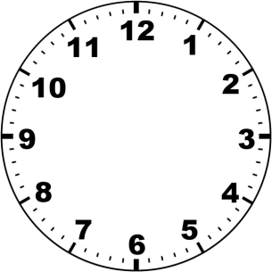
Converting measure of time
Mild/Spicy

Remember, there are 60 seconds in a minute and 60 minutes in an hour.
- How many seconds are there in 6 minutes? 60 seconds x 6 minutes =

- How many seconds are there in 25 minutes?

- How many seconds are there in 33 minutes?

- How many minutes are there in 4 hours?

- How many minutes are there in 6 hours 15 minutes?

- How many minutes are there in 9 hours 45 minutes?

- How many minutes are equal to 180 seconds?

- How many minutes are equal to 270 seconds?

- How many minutes are equal to 780 seconds?

- How many hours is 420 minutes?

- How many hours is 390 minutes?

- How many hours is 555 minutes?

Converting measures of time
Hot

- I cook a turkey for Christmas dinner for 5 hours 20 minutes, how much is this in just minutes?

- I bake a cake that needs 2 hours, 20 minutes in the oven, how long is this in minutes?

- I watch a football match that lasts 110 minutes, how long is this in hours and minutes?

- The school play runs for 555 minutes, how many hours and minutes is this?

- A marathon runner runs for a total of 890 minutes, how many hours and minutes is this?

- The marathon runner drinks water for a total of 11 minutes after the race has finished. How many seconds is this?

- It is 82 minutes and 5 seconds until my birthday! How many seconds is this?

- A train takes 77 minutes to travel to London, how many seconds is this?

- A diver can hold their breath for 5 minutes, how many seconds is this?

- My dog chases its tail for 230 seconds, how many minutes and seconds is this?

- A ballerina balances on one foot for 450 seconds, how many minutes and seconds is this?

- A bus is delayed for 672 seconds, how many minutes is this?

