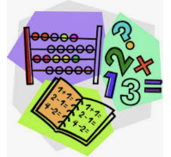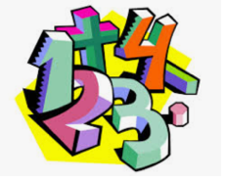

|  |  |
| --- | --- |
| **9 o’clock** | **5 o’clock** |
| **7 o’clock** | **3 o’clock** |
| **8 o’clock** | **1 o’clock** |