3D shapes
Vertices = corners

3D SHAPE | NAME | FACES | EDGES | VERTICES
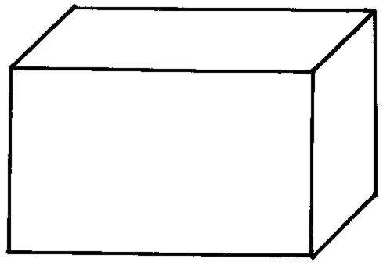

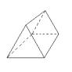
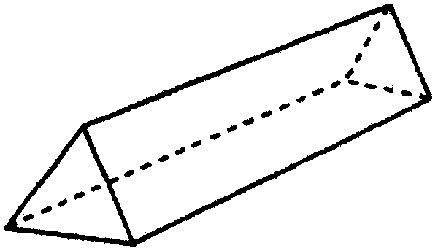

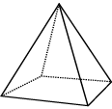

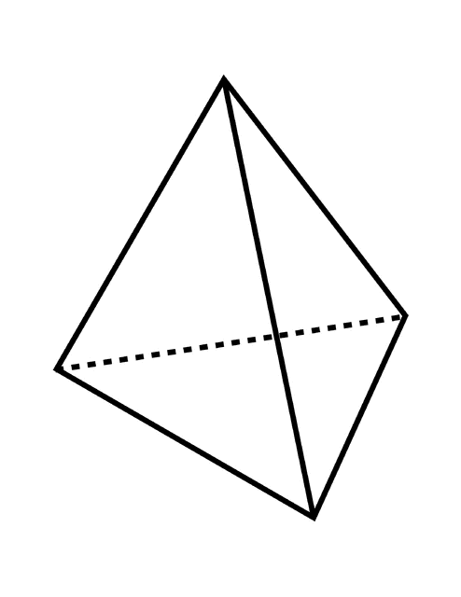

3D shapes
Vertices = corners

3D SHAPE | NAME | FACES | EDGES | VERTICES

